Conditionally Approve
Steps to create a Conditionally Approved Project:
- Select an agency, which gives the first three characters in project number
- Select a Program name, that gives the next first characters in project number
- Enter the last five characters in the project number, second character in the last five characters should match with payment method
- Project end date must be greater than begin project date
- Liquidation Date is calculated after 51st day after project end date
- In recap section Intake completed should be greater than Date Received in DOE
Fields with asterisk (*) are mandatory
- Creating a New Project
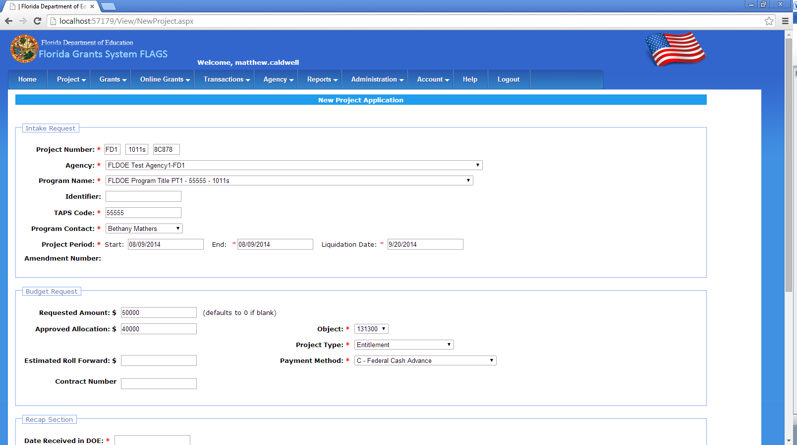
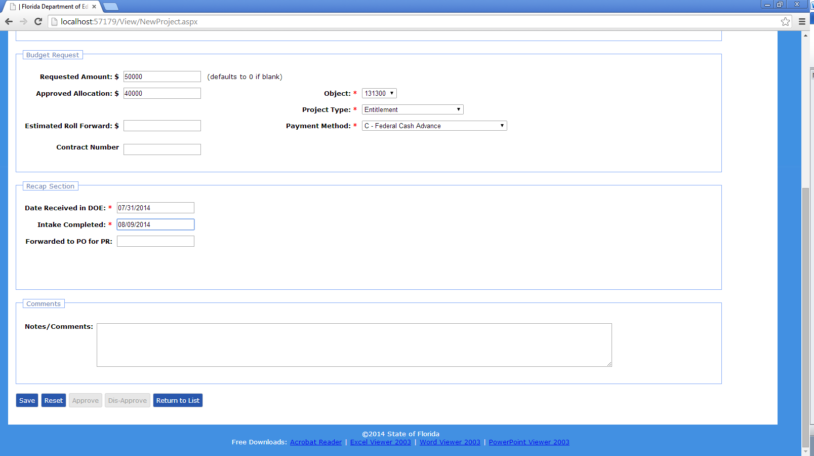
- Once a Project is created it was shown in ProjectApplicationList page with Status as New Application
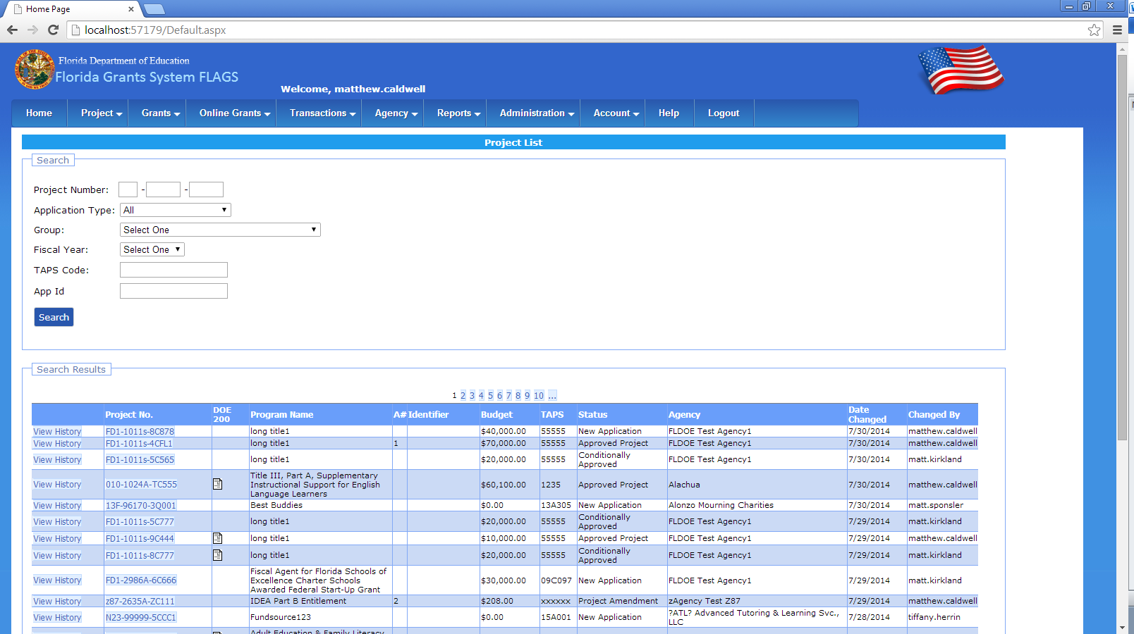
- After creating a new project open the project from project Application List by clicking on project no
- Select the Is Project CAEF as yes in change conditional Approval for entitlement funds section
- One fourth(1/4th) of Total project Amount is calculated and set as CAEF Amount automatically when the Is Project CAEF is Selected

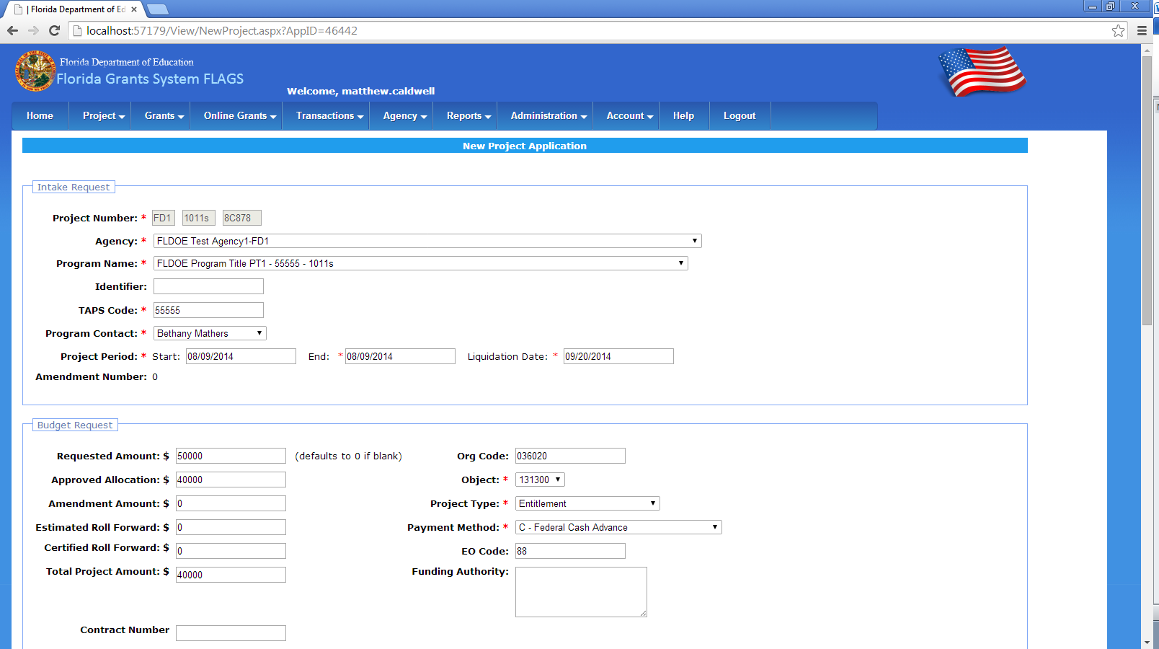
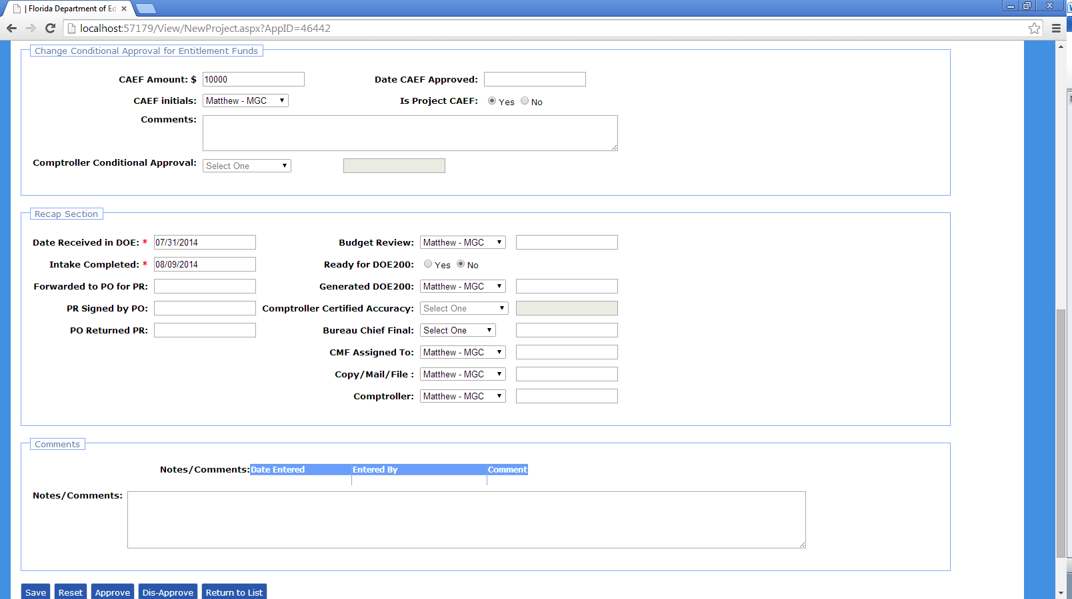
- Save the project. Once saved it is redirected to ProjectApplicationList Page

- Following roles can approve Conditionally approved project
- Internal/DOE
- Comptroller Sys Admin
- Base Agency Reviewer read-only
- Base Agency User
- Base Comptroller Reviewer
- Base Comptroller Accountant
- Base Comptroller Manager
- In the above mentioned roles home screen we can see the list of Conditionally Approved projects awaiting approval
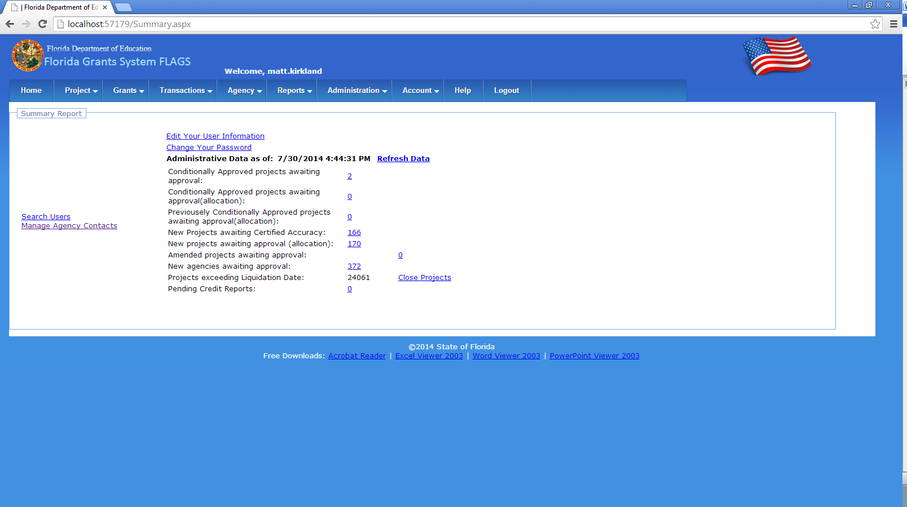
- Click on the Conditionally Approved projects awaiting approval link
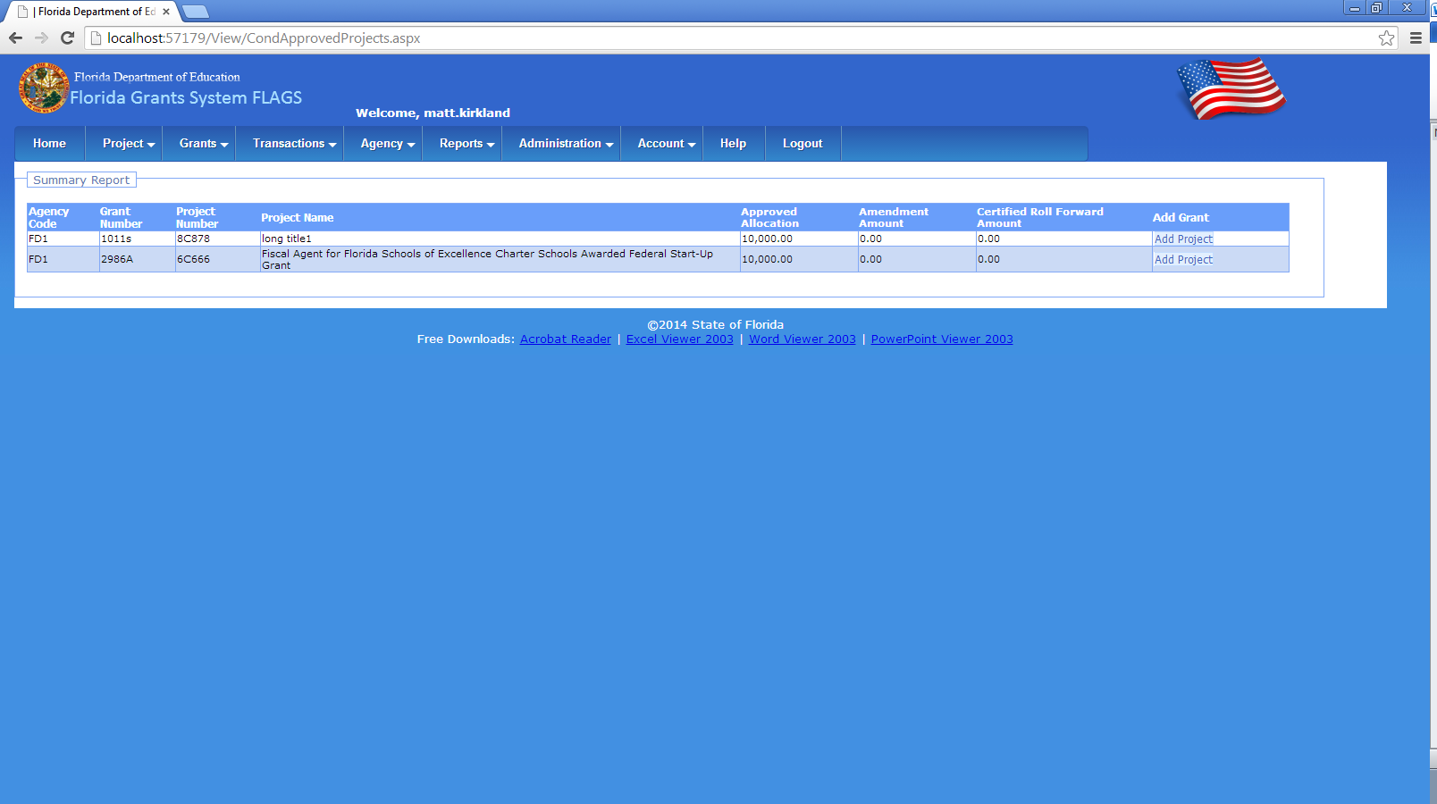
- Click on Add Project, redirects to the below mention page in the conditional Approval for entitlement funds section select comptroller conditional approval dropdown and date and click on approve
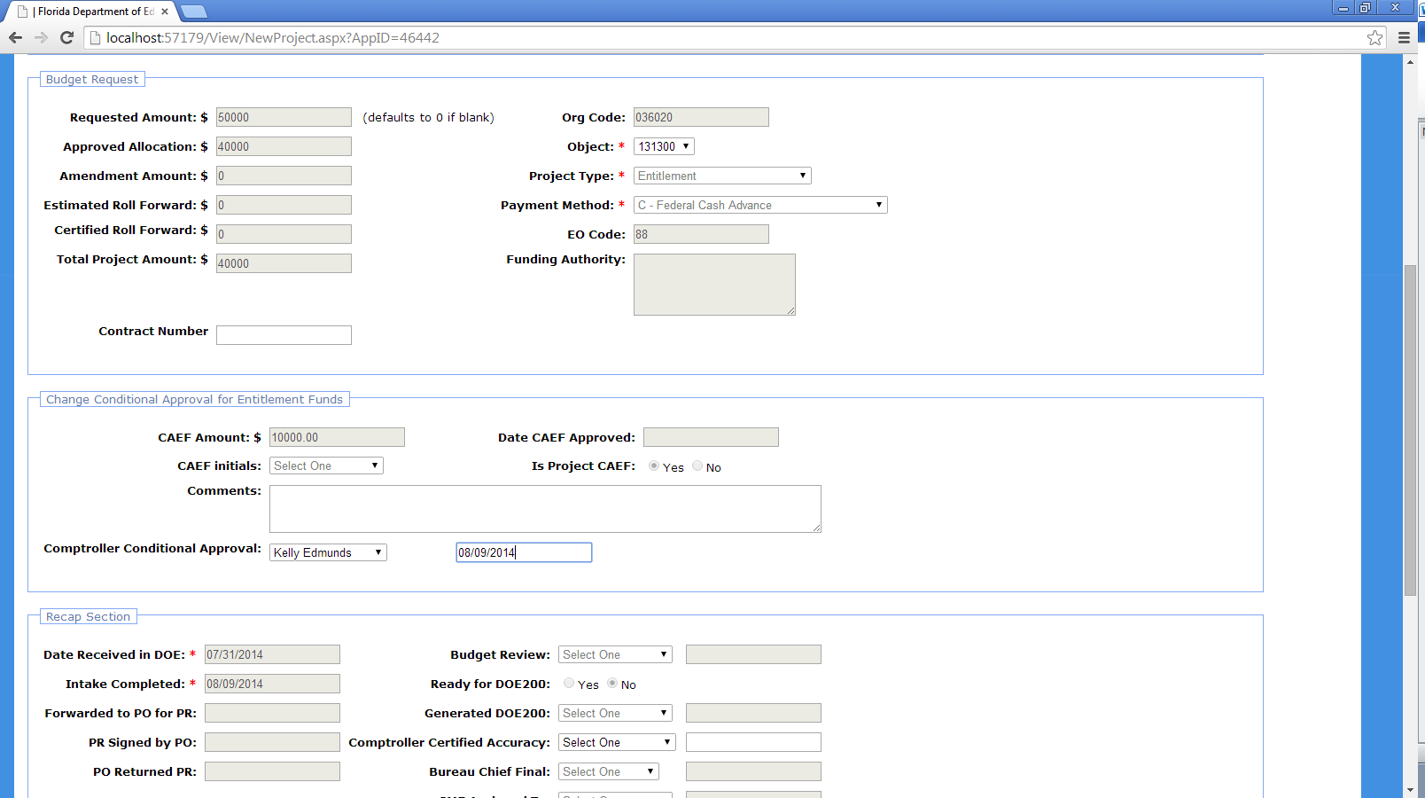
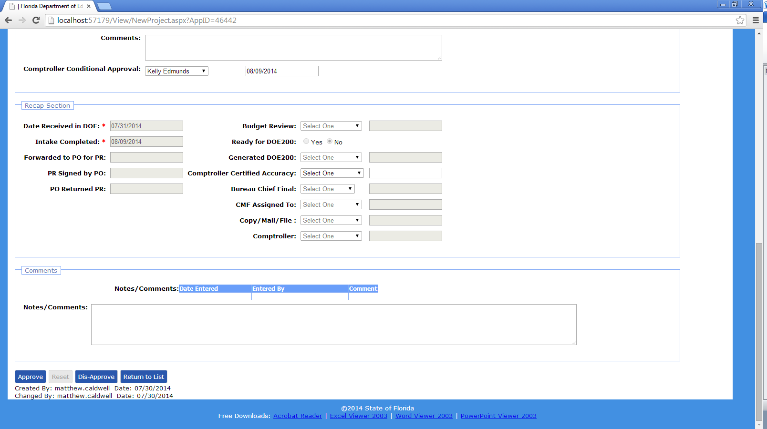
- Project status is changed to Conditionally Approved in ProjectApplicationList page
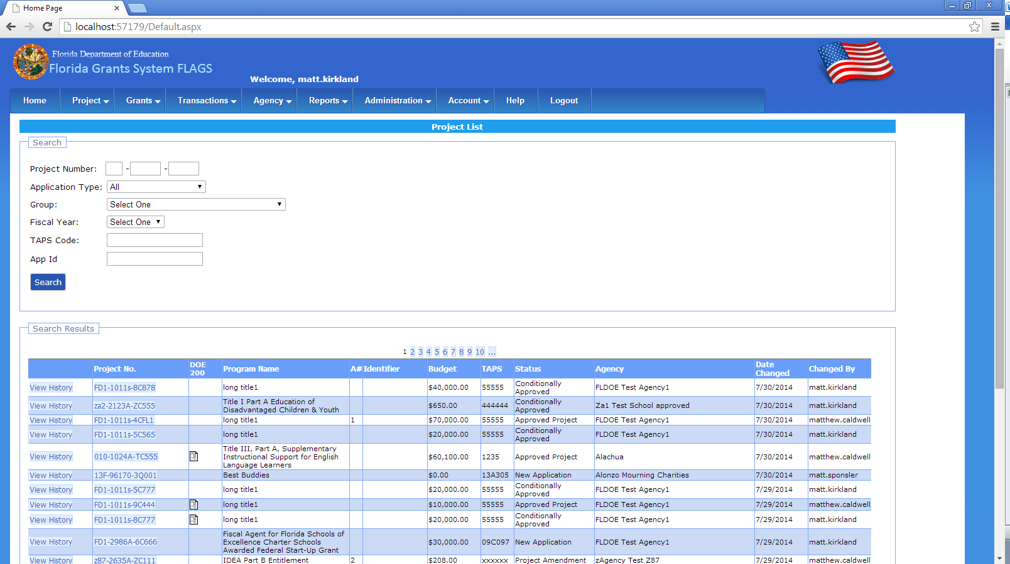

- Following roles can approve Conditionally approved project
- Internal/DOE
- Comptroller Sys Admin
- Base Agency Reviewer read-only
- Base Agency User
- Base Comptroller Reviewer
- Base Comptroller Accountant
- Base Comptroller Manager
- In the above mentioned roles home screen we can see the list of Conditionally Approved projects awaiting approval(allocation)
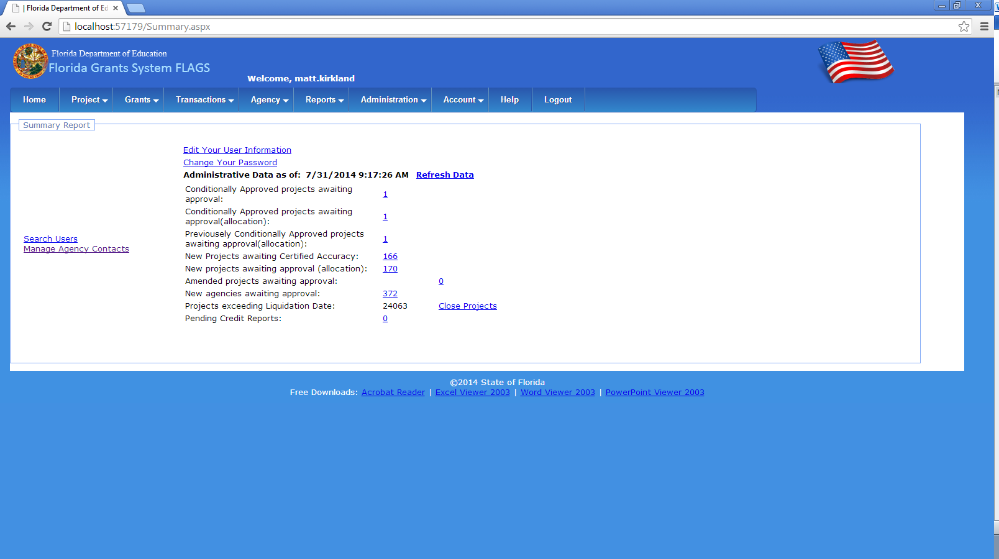
- Click on Conditionally Approved projects awaiting approval(allocation)
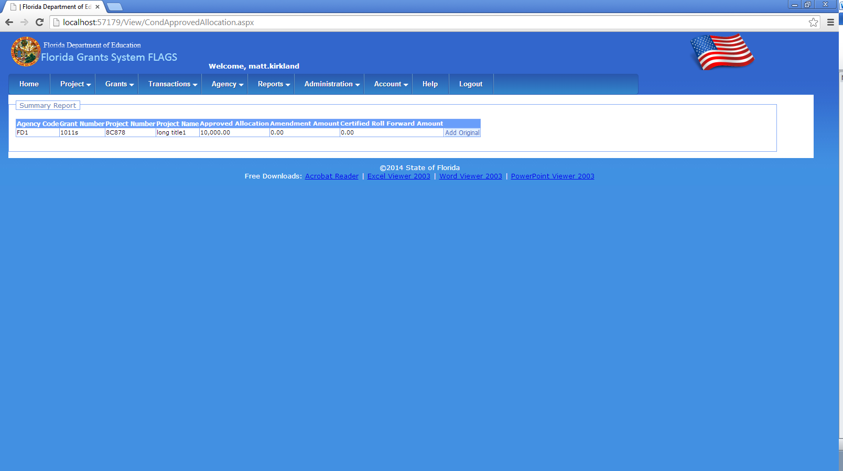
- Click on Add Original, redirects to projectmaster page
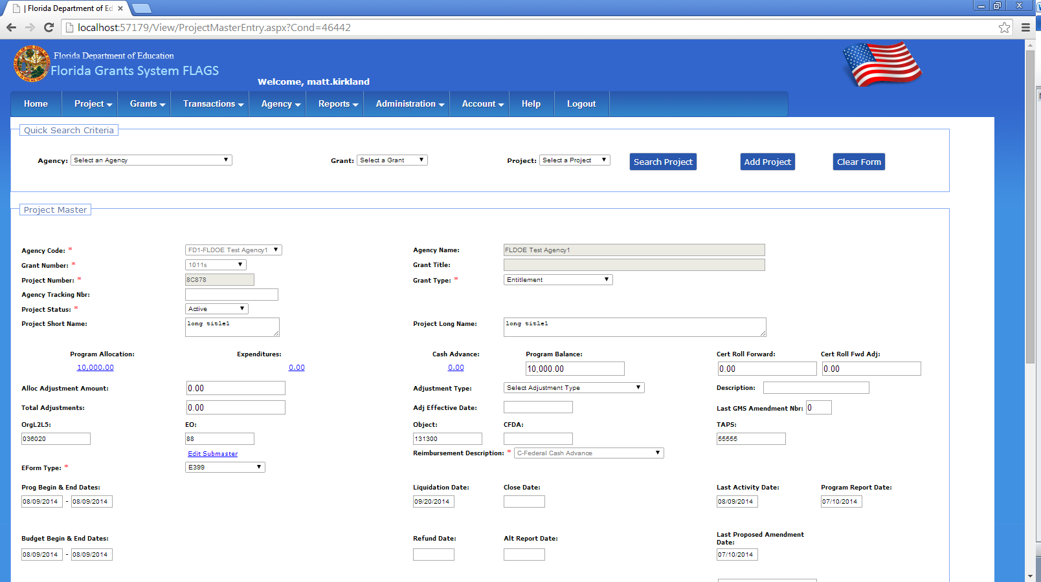
- Select the Status as active and save the project
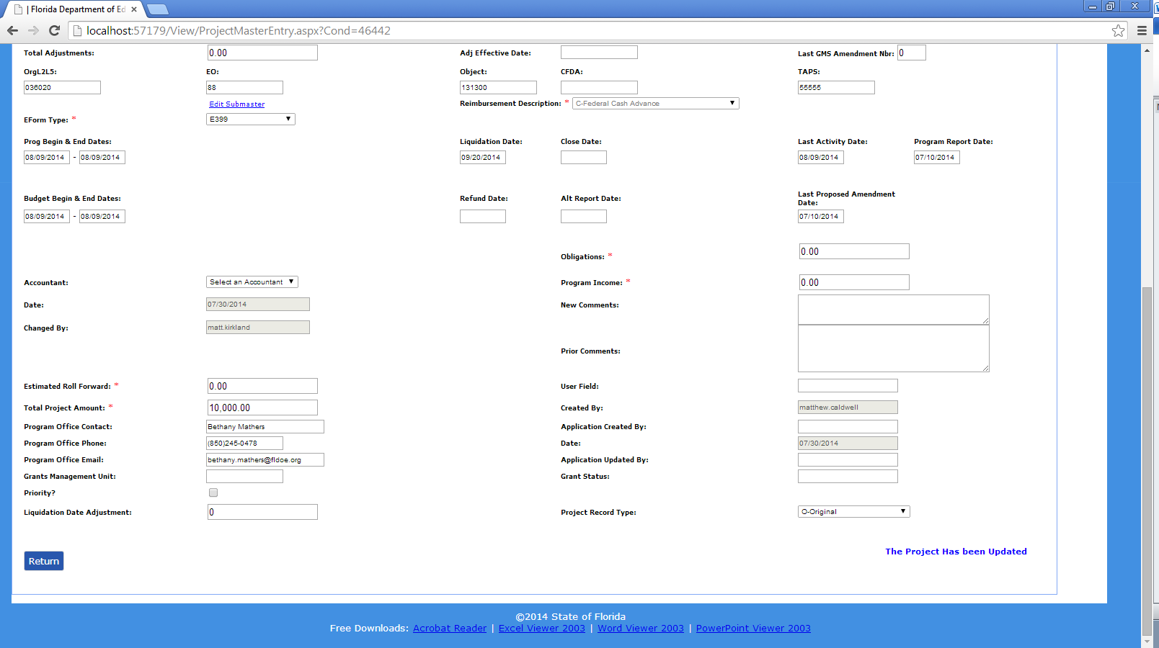
Then give the Forwarded to PO for PR date, PR Signed by PO date, PO Returned PR date, Budget Review date, Generated DOE200 date in recap section and save the project
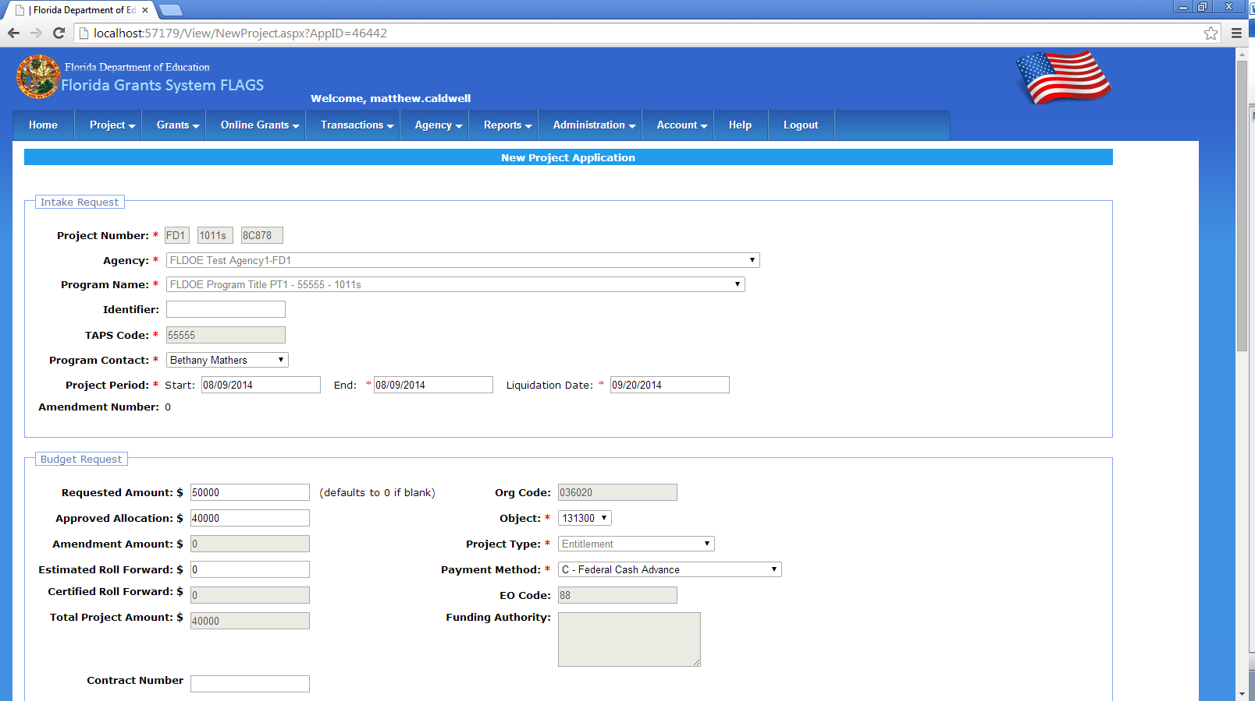

- Following roles can approve Conditionally approved project
- Internal/DOE
- Comptroller Sys Admin
- Base Agency Reviewer read-only
- Base Agency User
- Base Comptroller Reviewer
- Base Comptroller Accountant
- Base Comptroller Manager

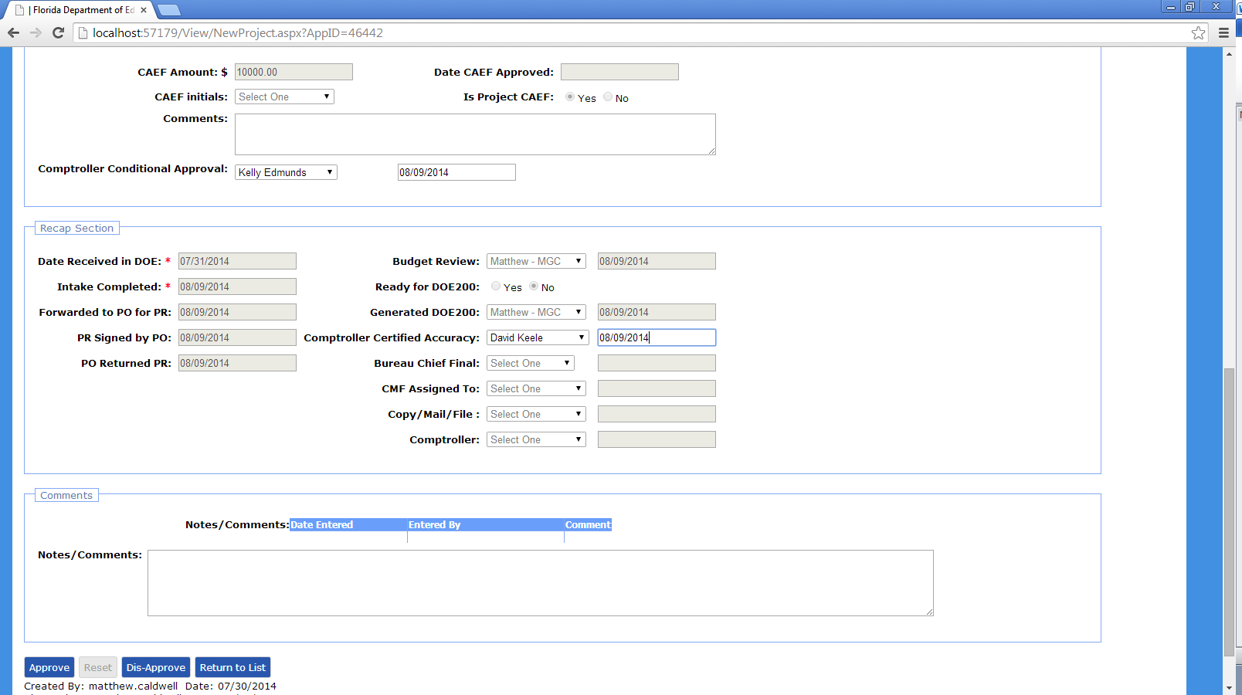
- Select a date for comptroller certified Accuracy and approve the project
- Fill the Remaining date in the recap section and save them
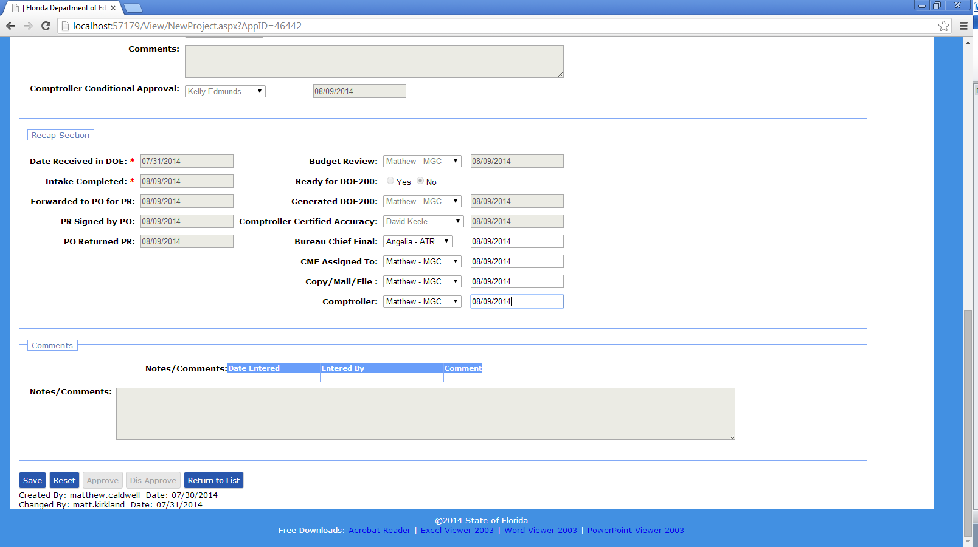
- Approve the project
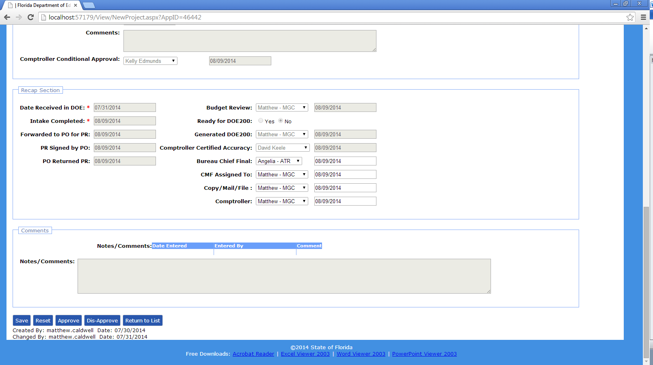
- The project status is changed to Approved Project in Project Application List
