FLAGS
Submitting an Amendment
After logging in to the FLAGS application, a Main Menu screen should appear similar to what appears in Figure 1 below.
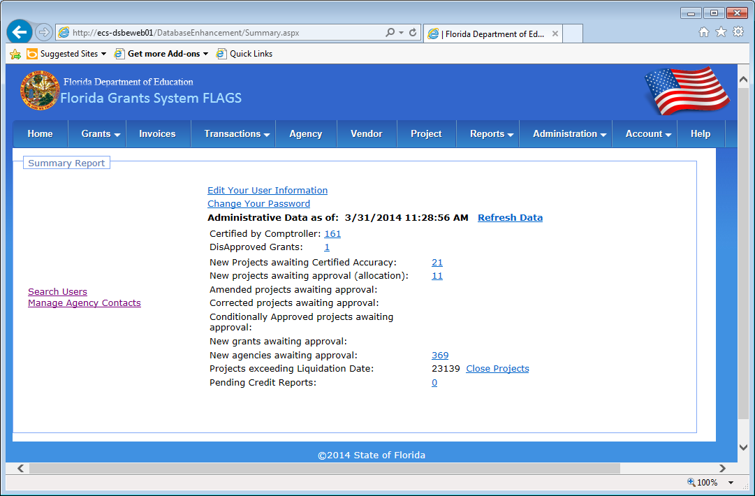
Figure 1 - FLAGS Main Menu

Hover over the “Grants” tab of the navigation bar at the top of the screen. This will expand a set of links below the Grants tab; select the “Online Grant Application” link that appear at the bottom of this list of links.
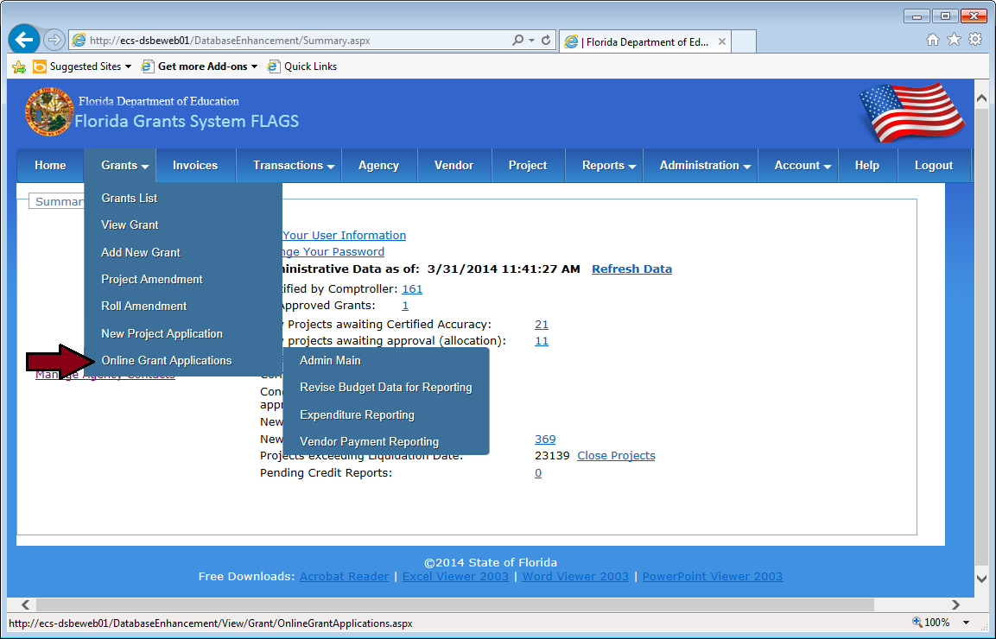
Figure 2 - Grant Applications Link
Next, click on one of the “Budget and SOW Requirements” links underneath an award. This will direct you to the Program Main Menu for that award. If no such links appear, your user account will need to be granted access to the Online Grant Applications section for an award.
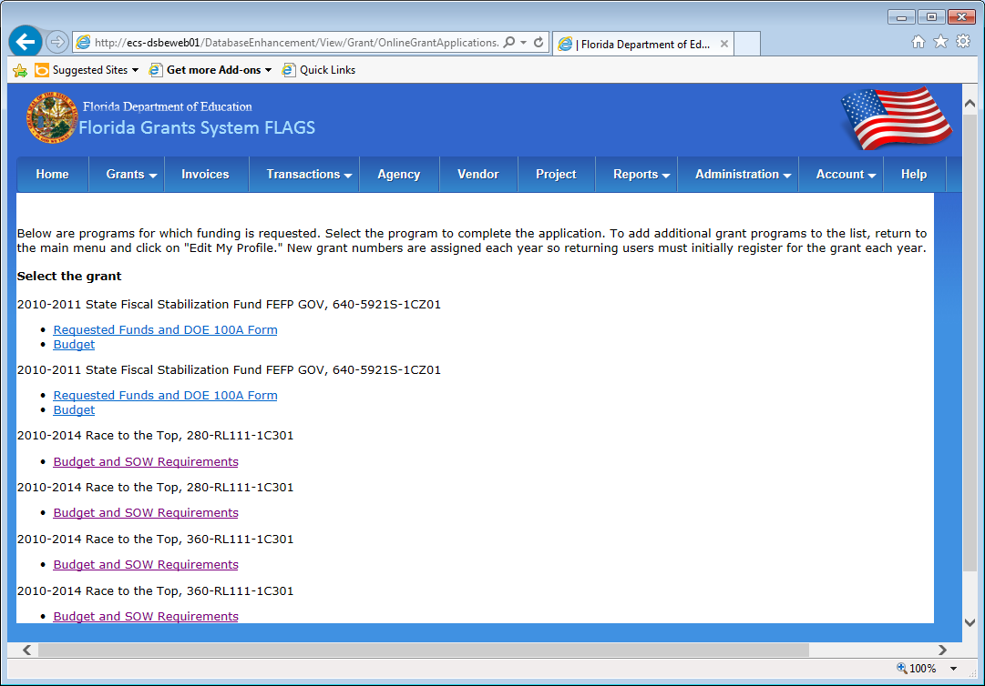
Figure 3 - Select a Grant
Figure 4 below shows the Program Main Menu page for an award with an open Budget Amendment and Scope of Work Amendment window. With the Amendment windows open, it will be possible to create and submit a new Amendment for the award. If the Budget and Scope of Work Amendment windows are closed, the page will indicate this, and it will not be possible to create an amendment until they are opened.
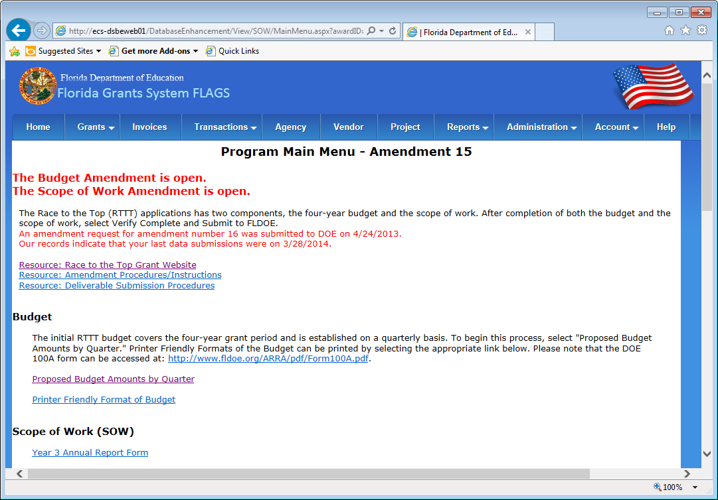
Figure 4 - Program Main Menu
The first step to creating a new amendment is to click on the “Set Up for Amendment” link found under the Scope of Work (SOW) section of the page. Figure 5 below indicates where to find the link on the Program Main Menu page. This will begin the process of copying data from the last approved amendment into a new set of amendment records for the current amendment window. The new records may be modified before submitting to FLDOE.
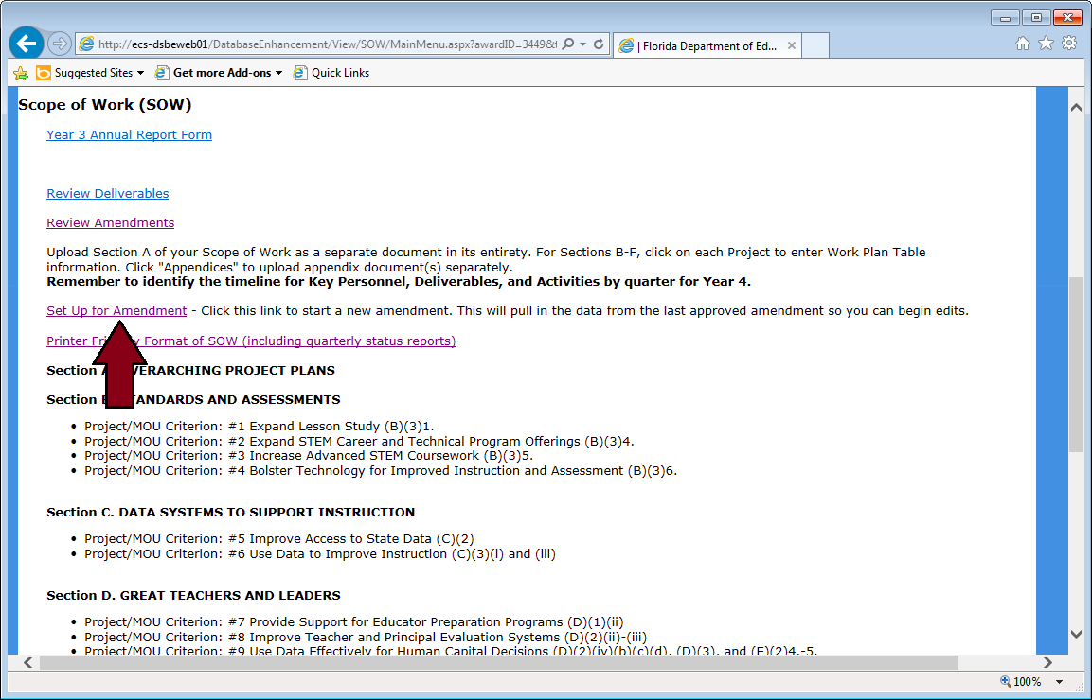
Figure 5 - Set Up for Amendment
After clicking the “Set Up for Amendment” link, a verification page (as shown in Figure 6 below) will appear once the new amendment records are created. After the page appears, click on the “Back to Program Main Menu” link to return to the Program Main Menu page.
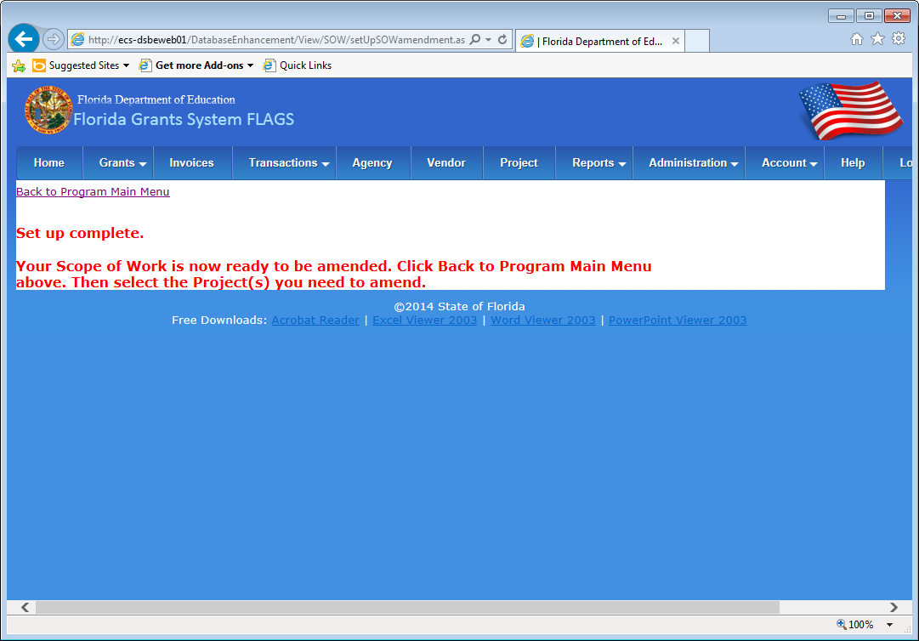
Figure 6 - Set Up Complete
After the new amendment records are created, the various sections of the award will be open for modification. Links to each section and project will be displayed under the Scope of Work (SOW) section of the Program Main Menu page. Click on any one of the project links to navigate to the Project Work Plan page for that project.
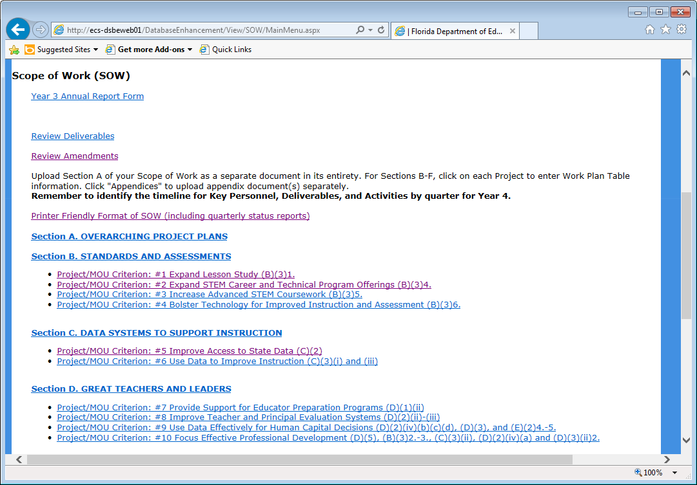
Figure 7 - Scope of Work Links

On the Project Work Plan page, a list of LEA points of contact for the project may be edited. The “Save point of contact” button will update any additions or modifications made to the list.
At the bottom of the Project Work Plan page, links are provided for the “Key Personnel”, “State Required Deliverables”, “District Required Deliverables”, and “Narratives” edit pages. Each of these edit pages are reviewed in the following pages and figures of this document.
Once all desired changes have been made to the work plan, click the “Back to Program Main Menu” link to return to the Program Main Menu page.
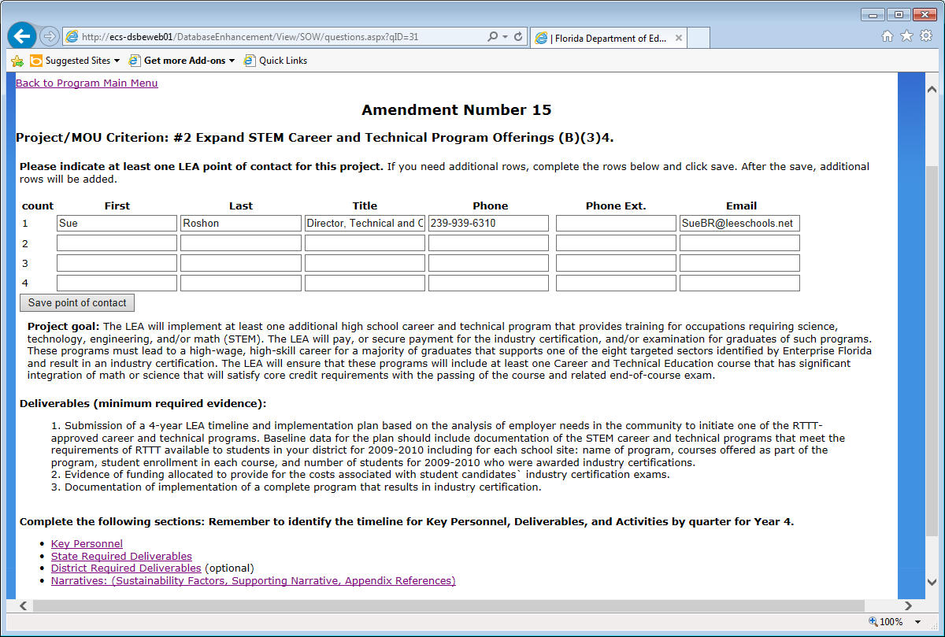
Figure 8 - Project Amendment Menu

The Key Personnel page provides an editable list of Personnel and which report quarters they apply to. Click the “Save Personnel” button at the bottom of the page to save any changes made to the list.
Click the “Back to Work Plan” link to return to the Work Plan page for this project.
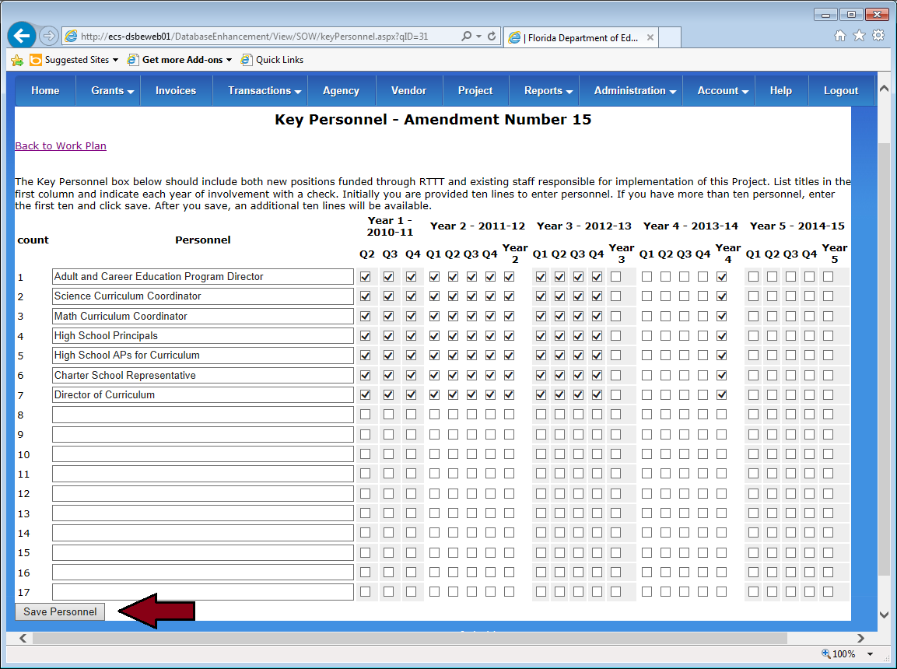
Figure 9 - Key Personnel
The State Required Deliverables page provides a list of Deliverables and Activities along with checkboxes to indicate the report quarters which they apply to.
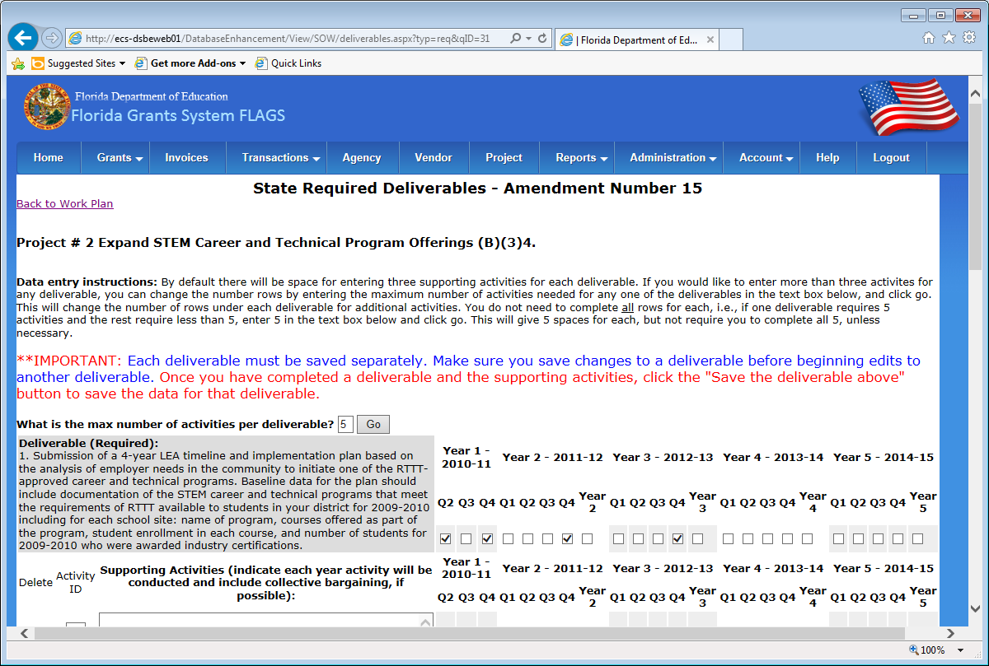
Figure 10 - State Required Deliverables
After making any modifications or updates to a deliverable or activity, click on the “Save the deliverable above” button to save your changes.
Click the “Back to Work Plan” link to return to the Work Plan page for this project.
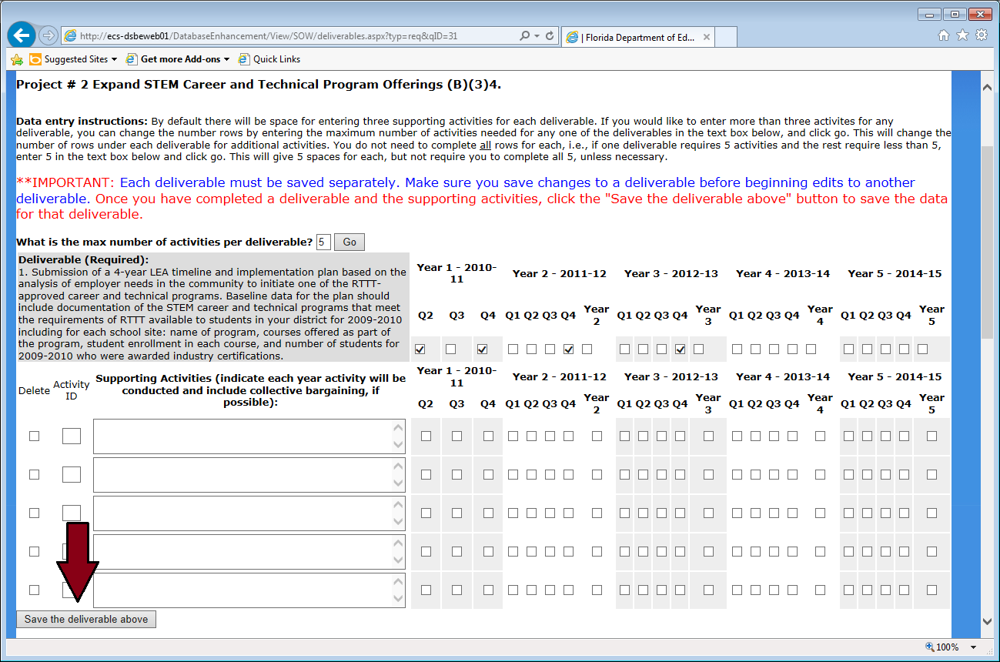
Figure 11 - State Required Deliverables (Save)
The District Required Deliverables page is mostly identical to the State Required Deliverables page with the exception that the description field for a deliverable is editable, which on the State Required Deliverables page, is a fixed value.
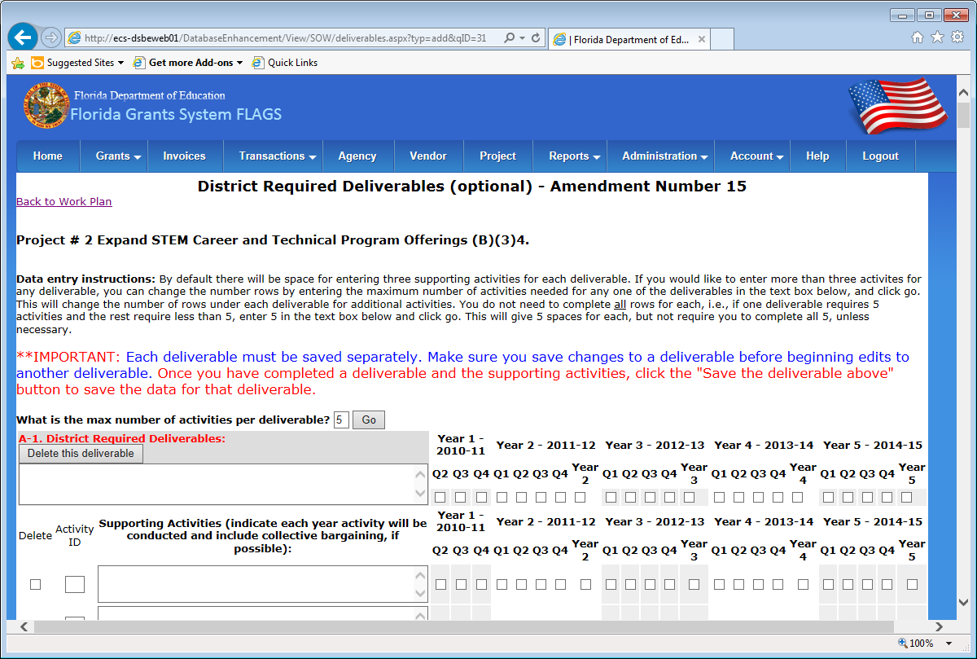
Figure 12 - District Required Deliverables
Again, make any desired changes to a deliverable or its activities, and then click on the “Save the deliverable above” button found below the modified deliverable.
Click the “Back to Work Plan” link to return to the Work Plan page for this project.
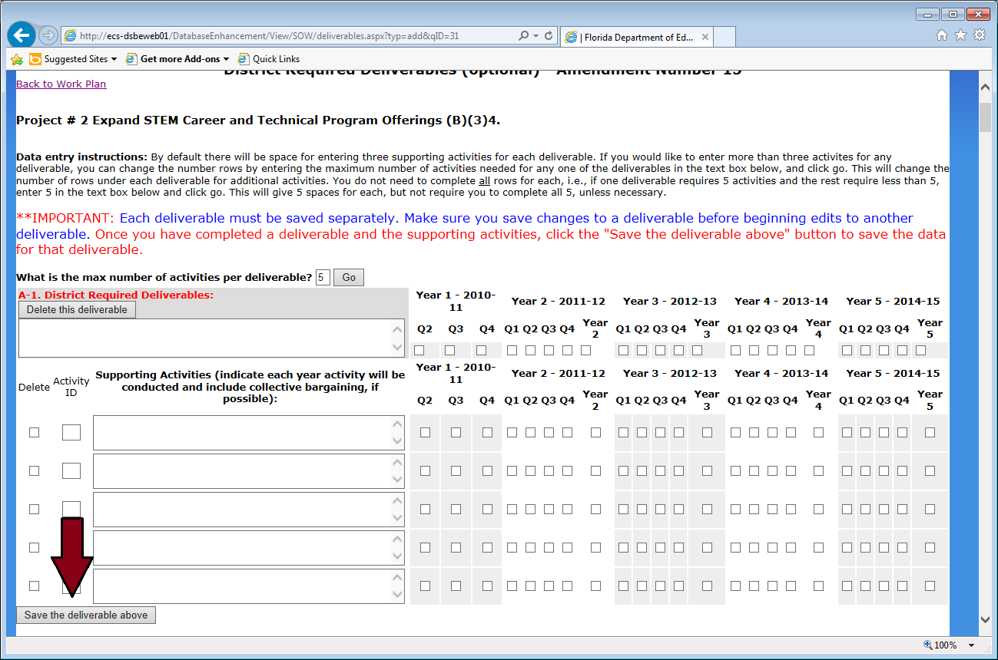
Figure 13 - District Required Deliverables (Save)
The Narratives page offers three editable text boxes, including “Sustainability Factors”, “Supporting Narrative (optional)”, and “Title and Page Number of Appendices for this Project (if applicable)”. Make any desired changes and then click on the “Save” button at the bottom of the page.
Click the “Back to Work Plan” link to return to the Work Plan page for this project.
Once all desired changes have been made to the Work Plan, click the “Back to Program Main Menu” link to return to the Program Main Menu page.

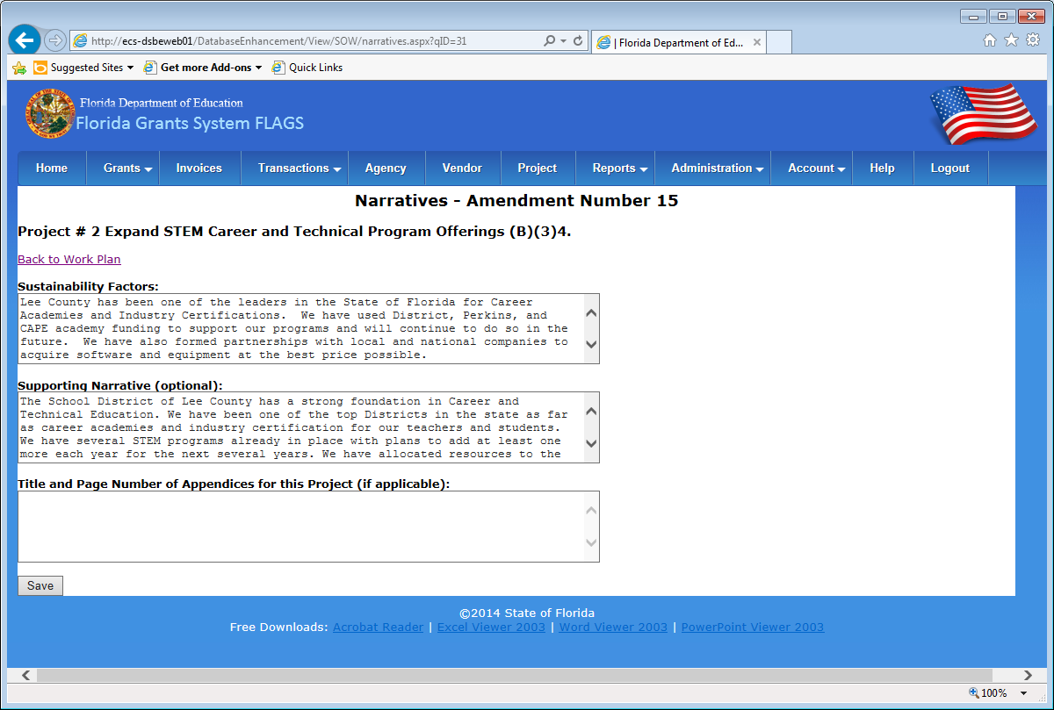
Figure 14 - Narratives
The next step in creating an amendment is to create and make modifications to the Proposed Budget. Click on the “Proposed Budget Amounts by Quarter” link found under the “Budget” section of the Program Main Menu page (as found in Figure 15 below).
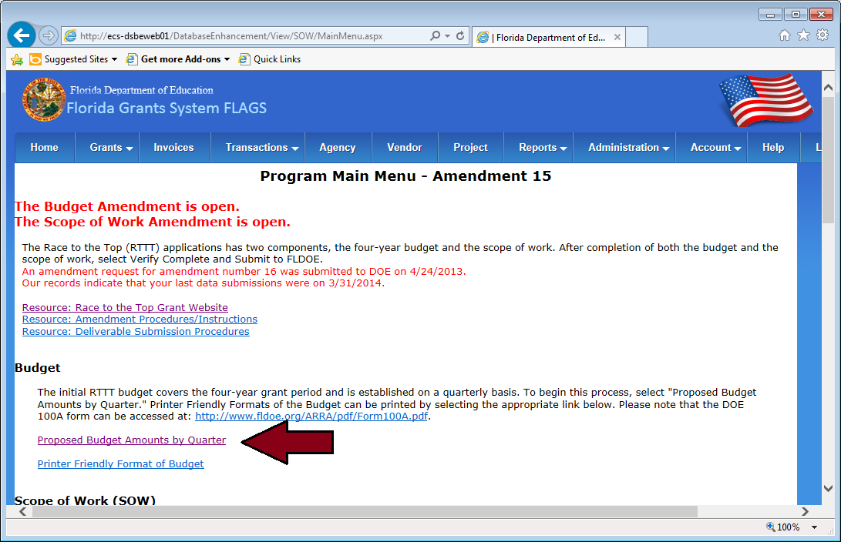
Figure 15 - Proposed Budget By Quarter
When first arriving on the Quarterly Budget Amendment page for a new amendment, the budget from the most recently approved amendment will be displayed. After making any desired changes to the budget, click the “Save” button found on either the top or bottom of the page and a new set of budget records will be created for the current amendment window.
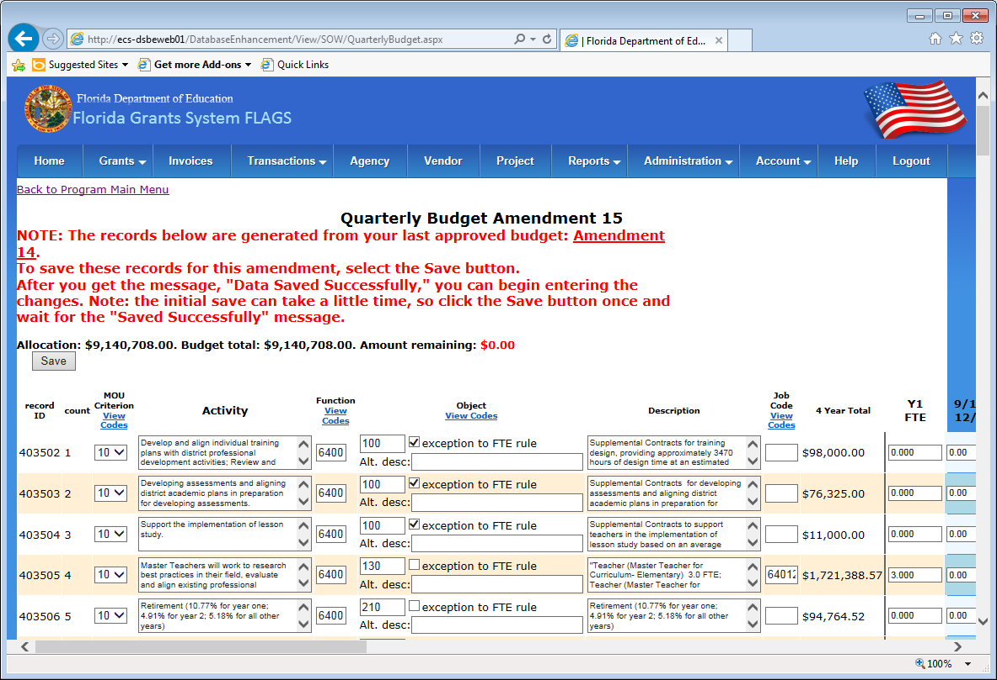
Figure 16 - Quarterly Budget
After the new budget records have been created, a verification message will be provided as seen in Figure 17 below. Click on the “Program Main Menu” link to return to the Program Main Menu page.
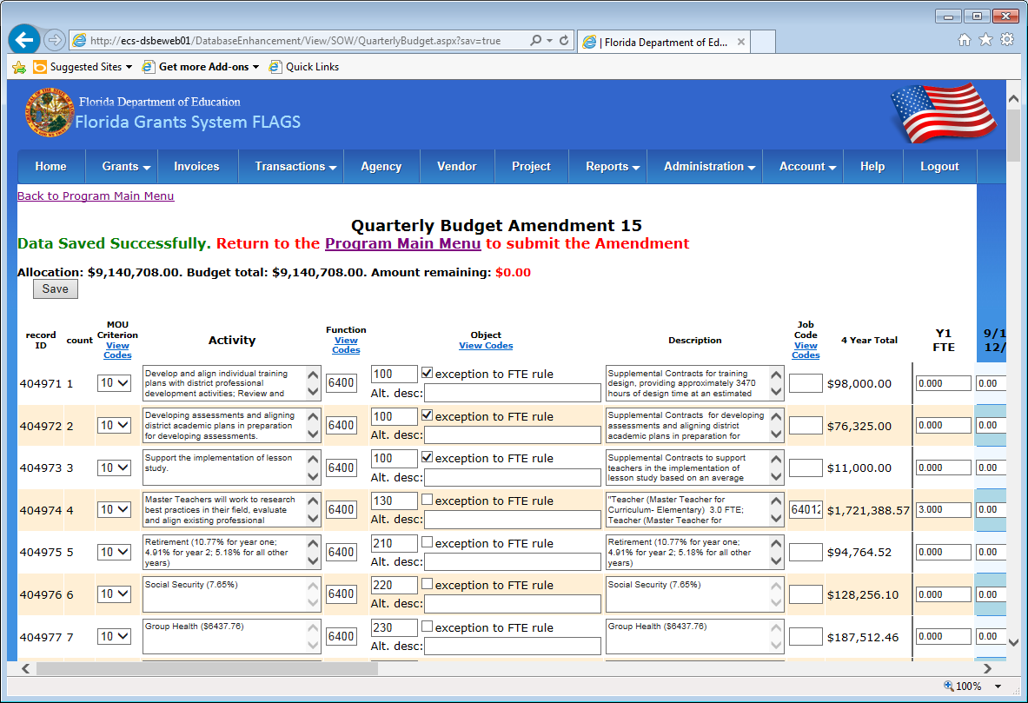
Figure 17 - Quarterly Budget (Saved)
After all desired changes have been made to the budget and scope of work, it is time to submit the amendment to FLDOE. Click on the “Verify Complete and Submit Amendment to FLDOE (Note: Verification takes time, so click once and wait)” link found under the Verification and Final Submission of Amendments section of the Program Main Menu page (as indicated in Figure 18 below).
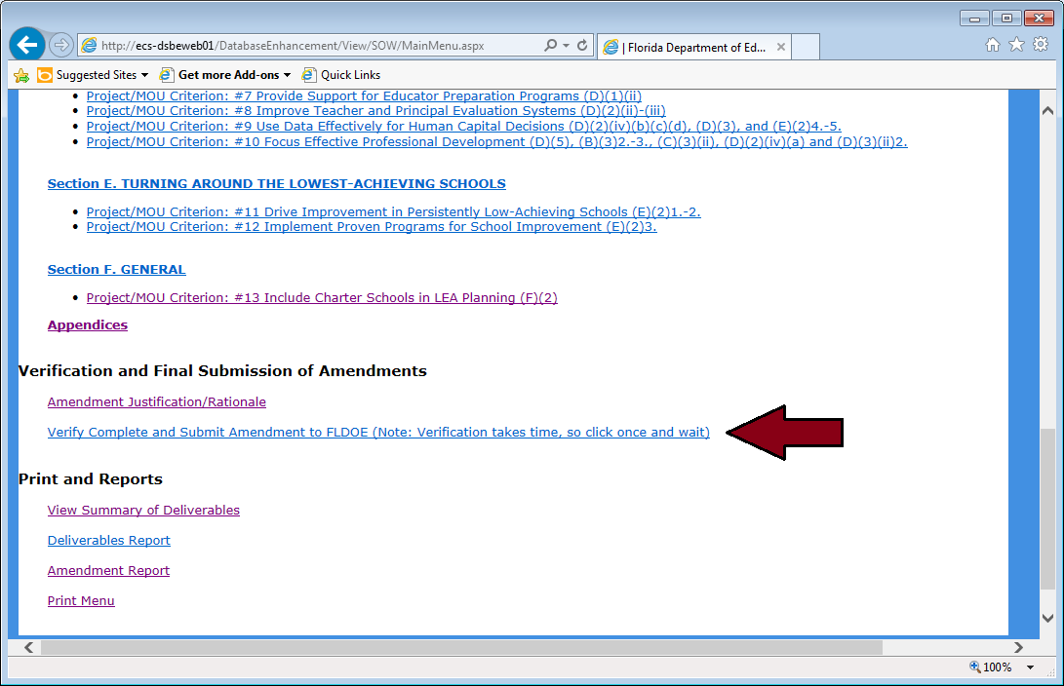
Figure 18 - Verify Complete
After the amendment is verified, the Final Submit page will appear as seen in Figure 19 below. This is the last step before submitting the amendment to FLDOE. A DOE 160 Form must be filled out, converted into a .pdf document and provided in the file input box before the submission may be processed. After supplying the .pdf document using the “Browse…” button, click the “Submit my data to FLDOE” button to finalize the submission process.
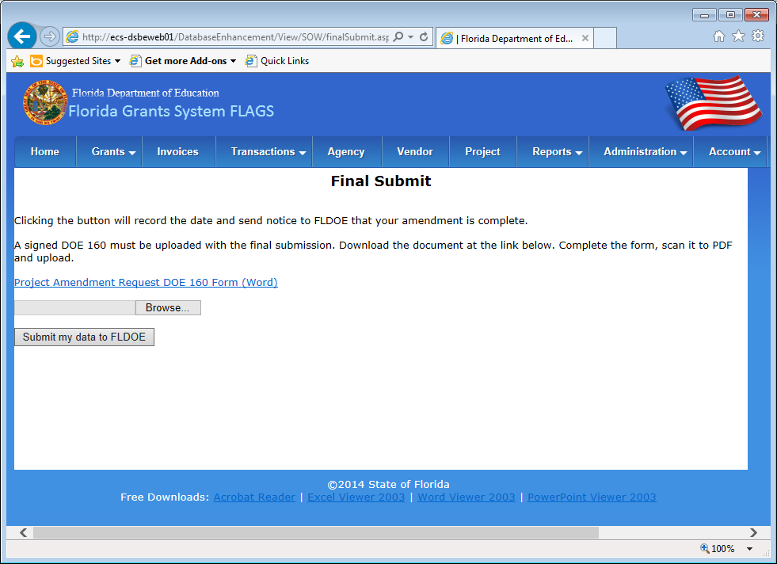
Figure 19 - Final Submit
After submitting the amendment, the user will be redirected to the Program Main Menu page. Note that the submission process has closed the Budget and SOW amendment window (as indicated by the red text at the top of the Program Main Menu page – see Figure 20 below). This concludes the amendment process, until another amendment window is opened by FLDOE.
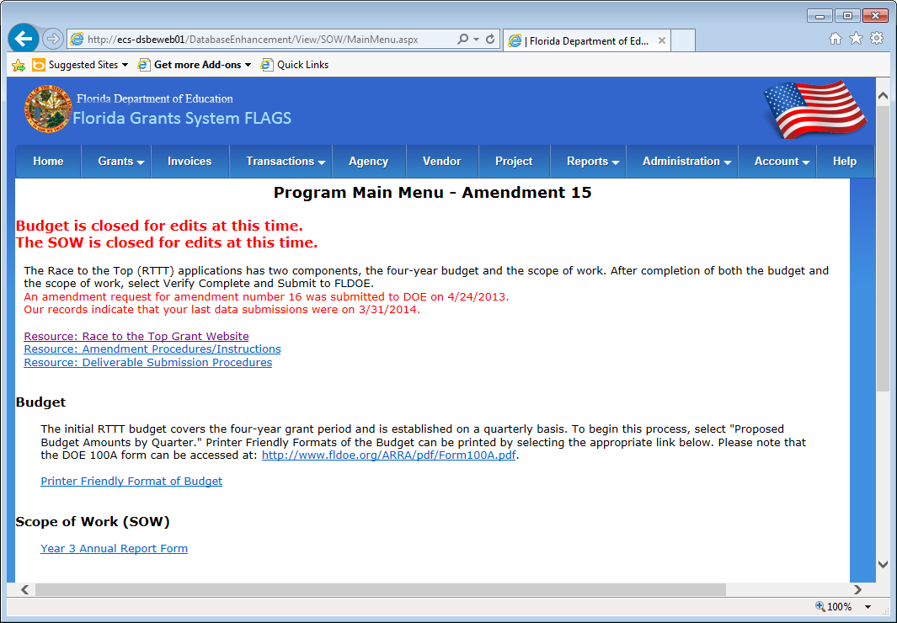
Figure 20 - Program Closed for Edits

