**New Agency**

**A new Agency can be created by (Roles):**

1. Flags Admin
2. Flags Read-only
3. Internal/DOE
4. Comptroller Sys Admin
5. Base Comptroller Reviewer

**Steps to Create an Agency:**

1. Agency Code is Unique
2. User can add a new agency without an agency code only when **agency approved** Radio button is **selected as NO** (All the approved agencies should have the Agency Code)

Fields with asterisk (*) are mandatory

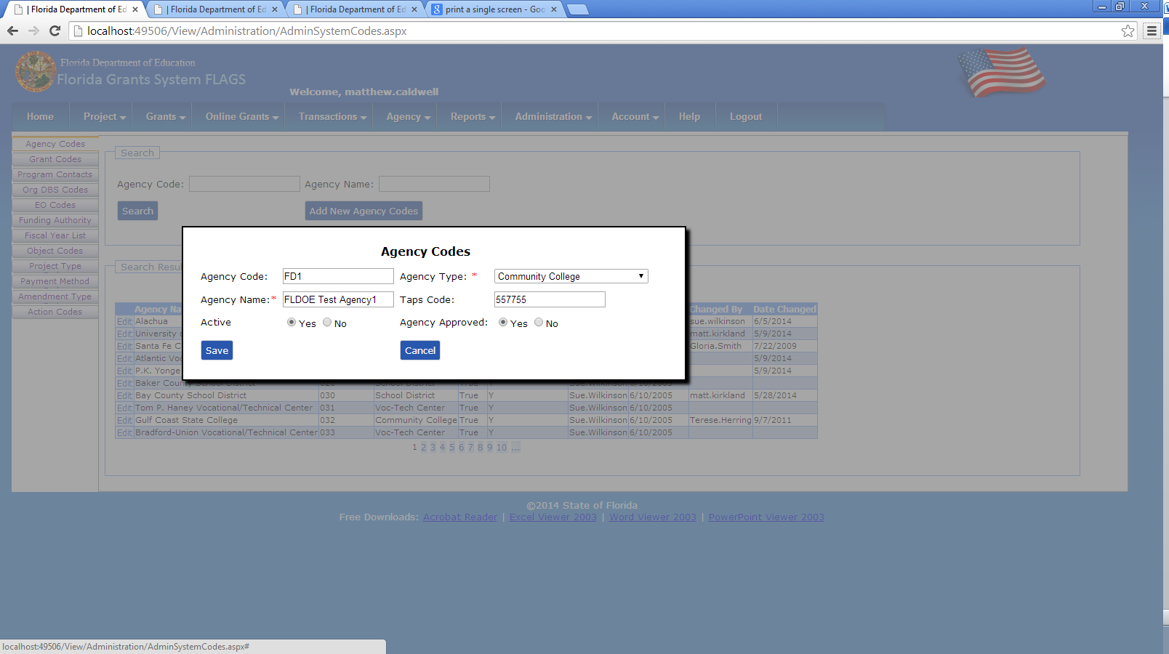

1. After Creating the Agency it can be seen in Agency Codes tab
2. All the agencies (inactive & not Approved) can be seen in agency codes tab

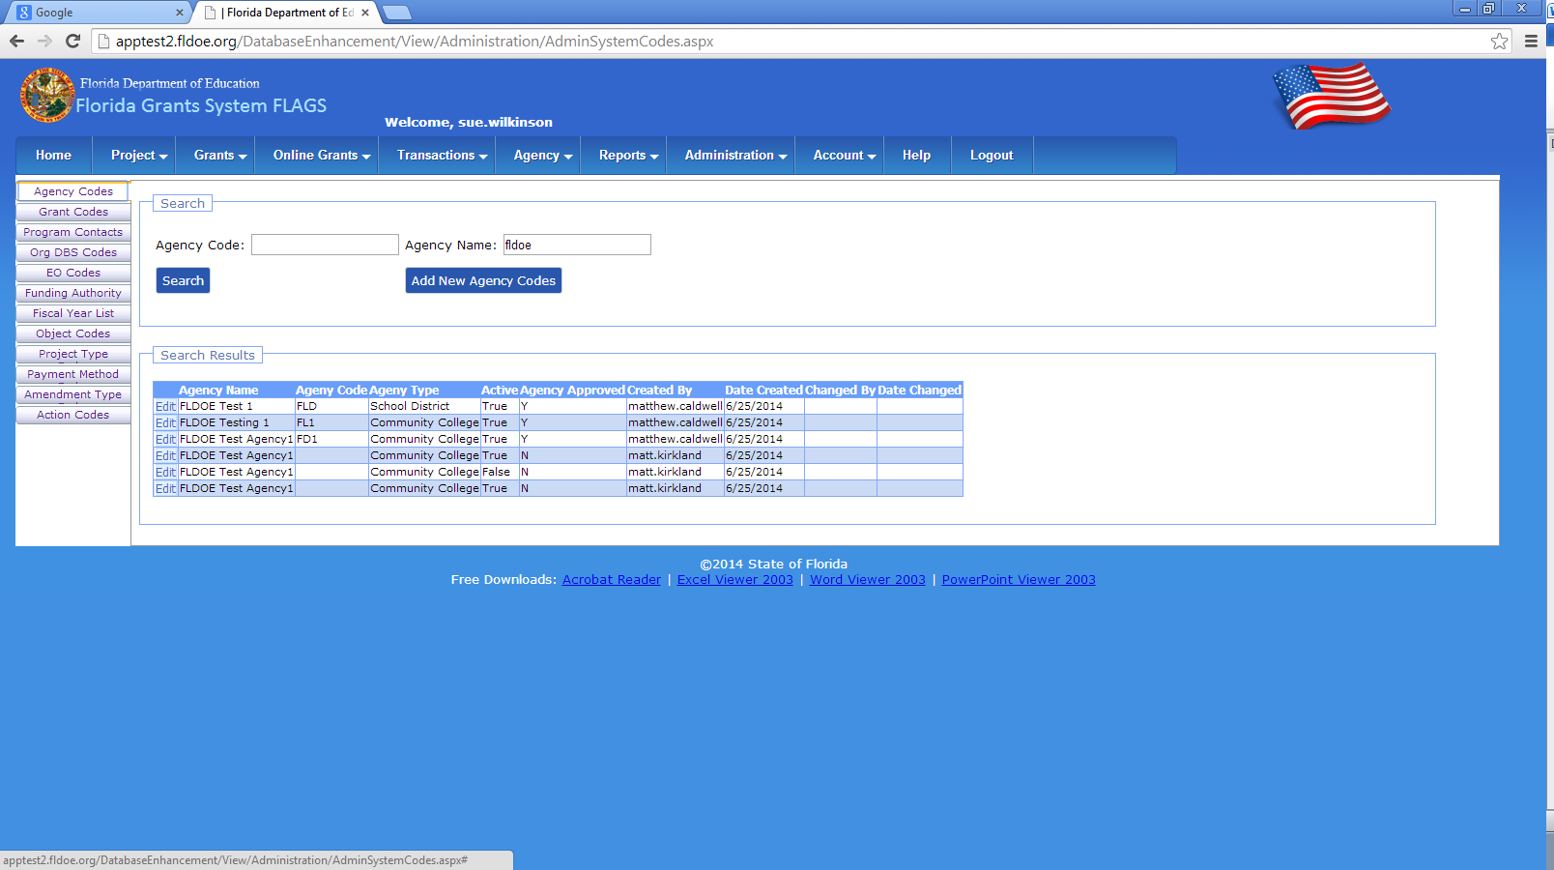

1. To retrieve the agencies from the menu item(Agency): Only active agencies were shown

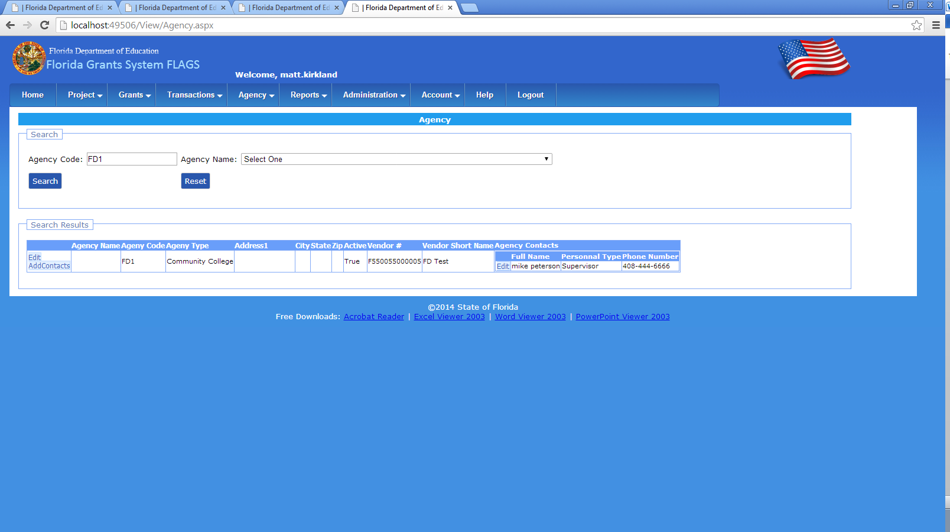

1. Once an agency is created it was shown in New Project Application Page

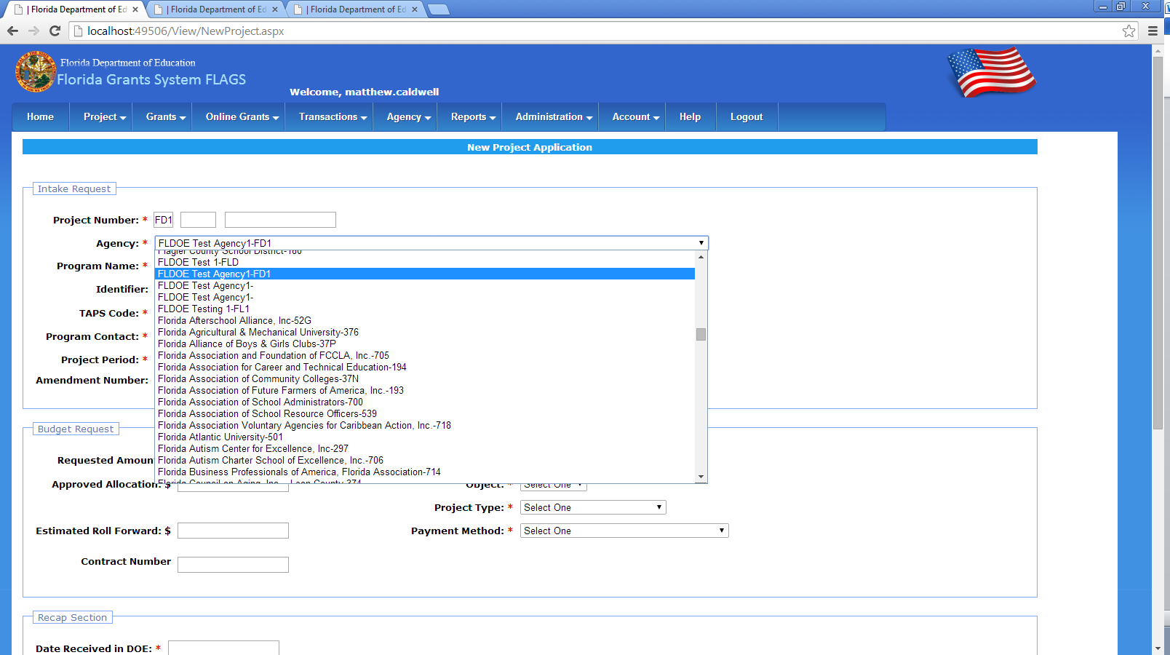

1. Add an agency contact
2. A user can add multiple contacts to an Agency

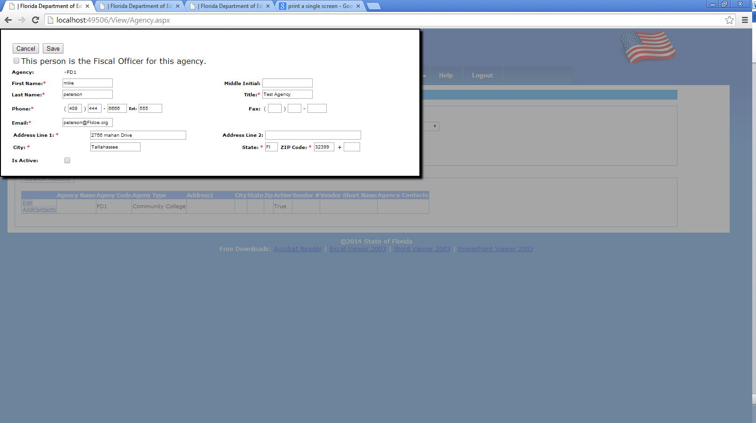

**To create a new vendor for an agency**

**Roles to create a vendor:**

1. Flags Read-only
2. Internal/DOE
3. Comptroller Sys Admin

1. Agency Code must be given to add a vendor

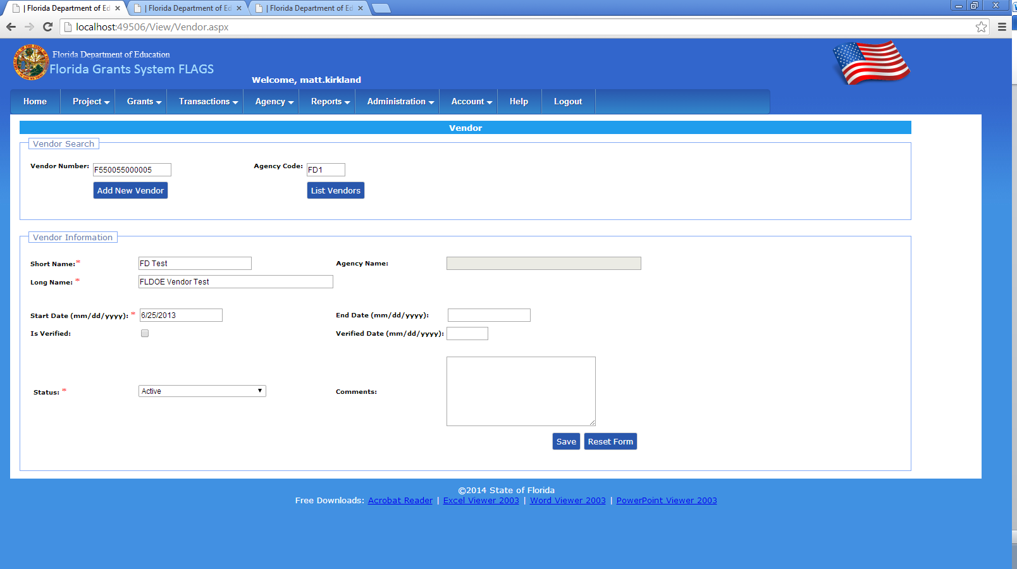

1. Once a vendor is created it can be seen in vendor page

