Project Allocation
A project Allocation can be created by (Roles):
- Internal/DOE
- Comptroller Sys Admin
- Base Comptroller Reviewer
- Base Comptroller Accountant
- Base Comptroller Manager
Steps to approve a project:
- From the comptroller home screen click the New Project awaiting approval
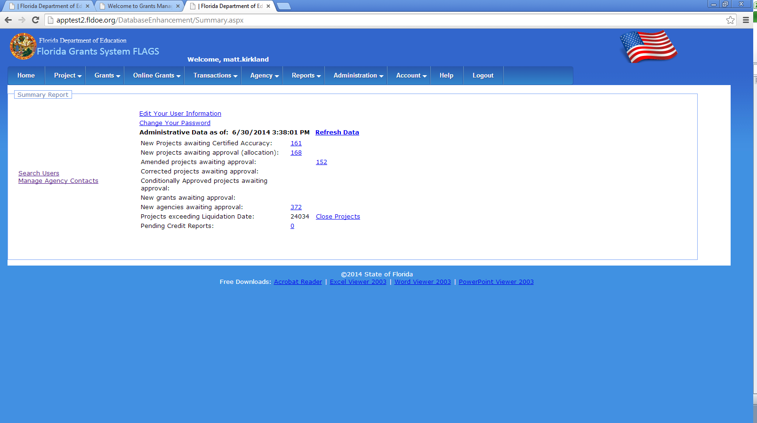
- Opens the all the new projects awaiting approval
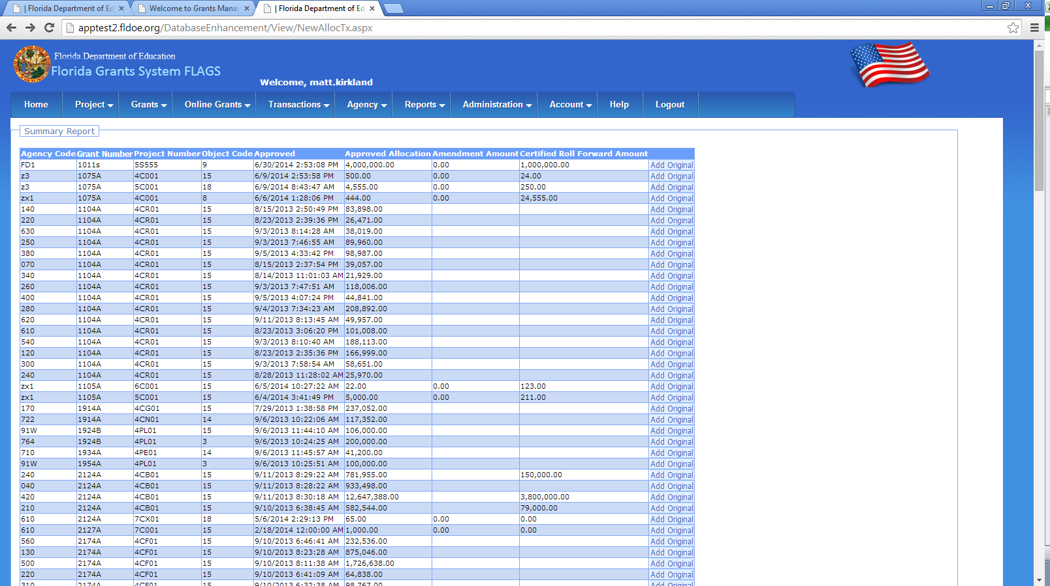
- Click on add original redirects to project master page
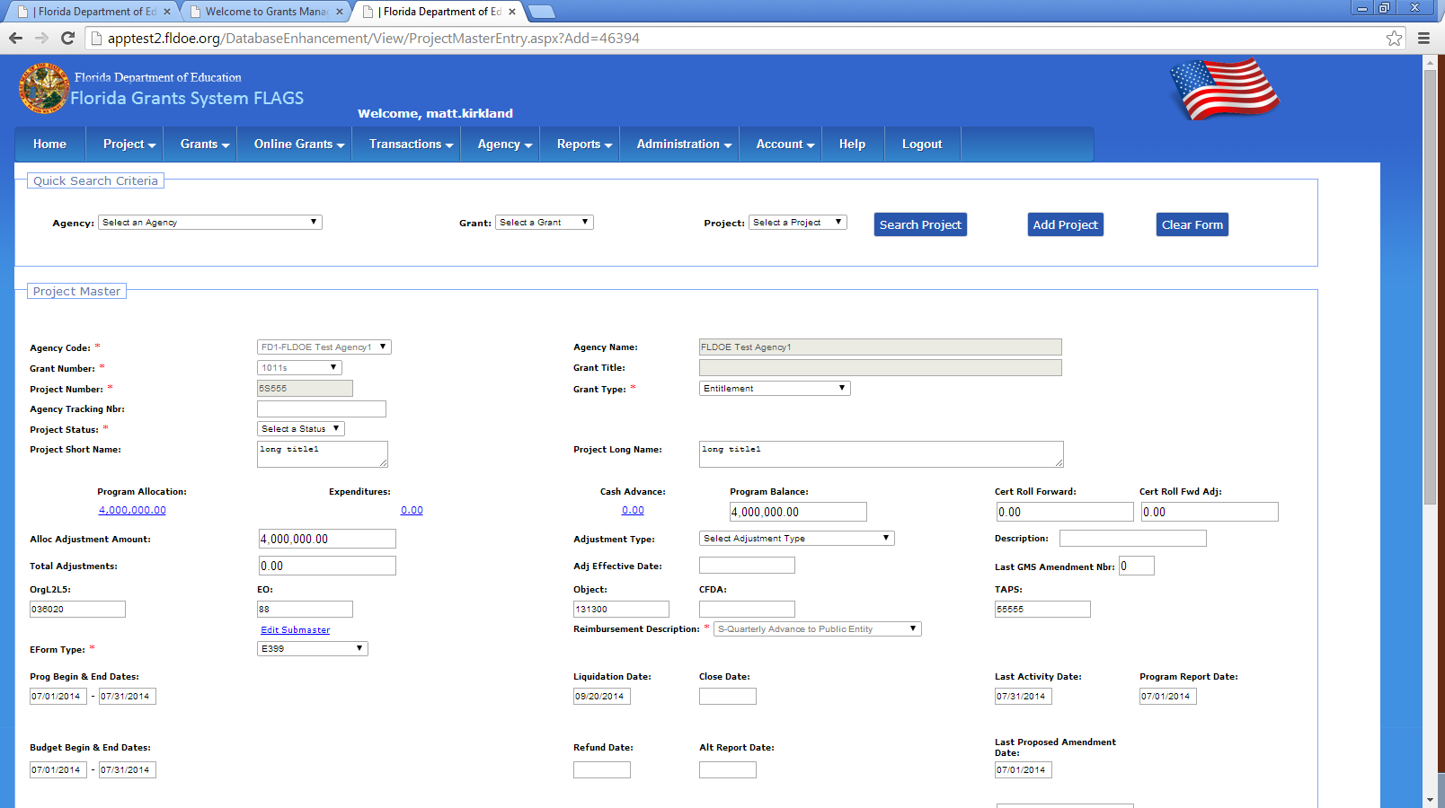
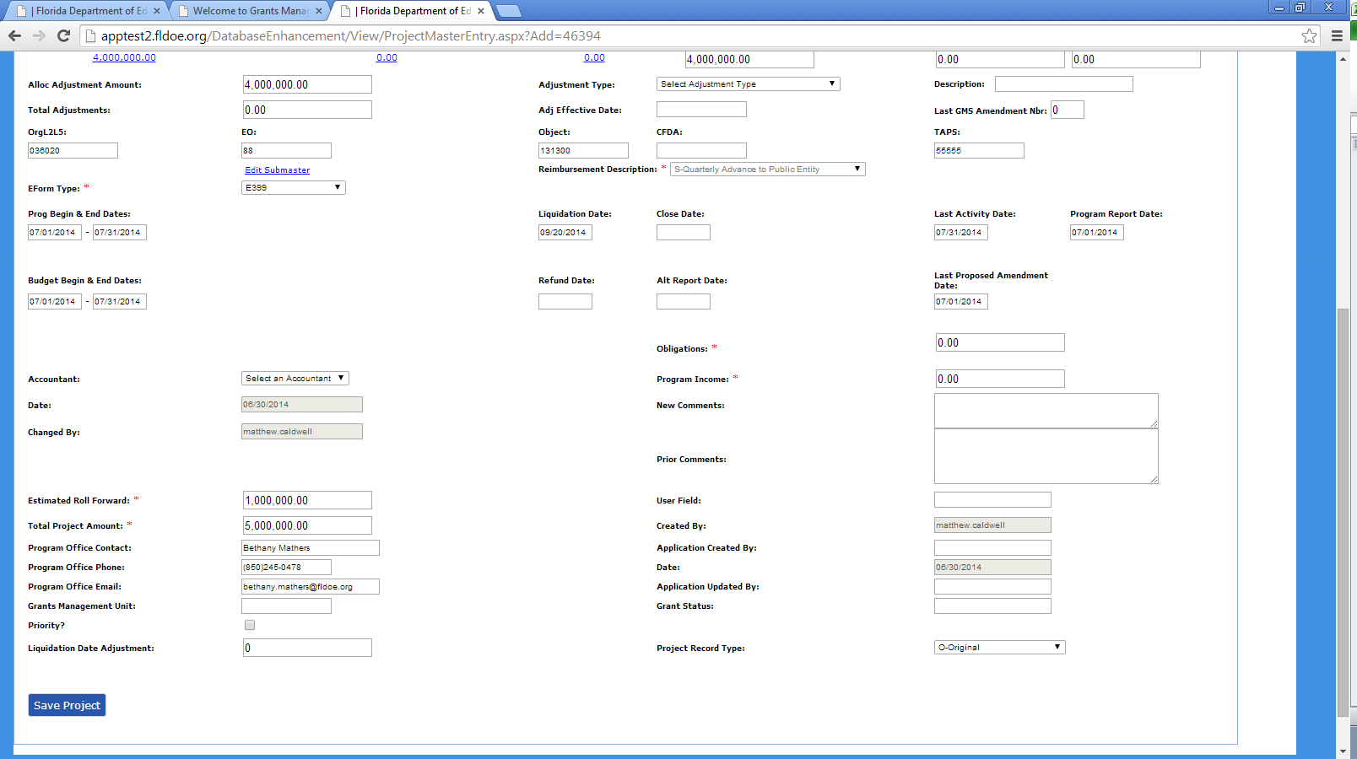
- Project State must be selected
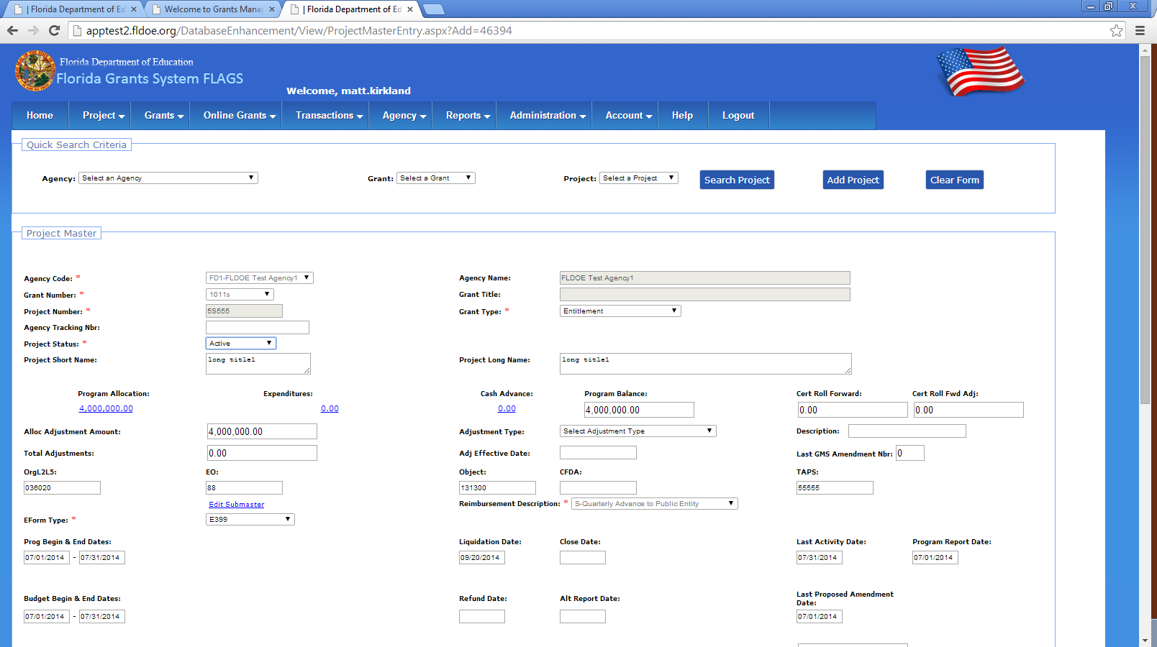
- Save the project, After saving the project it the record can’t be seen in Comptroller home New Project awaiting approval list
