Project Amendment to Allocation & Transaction
Project Amendment can be done by (Roles):
- Flags Admin
- Flags User
- Flags Read-only
- Internal/DOE
- Comptroller Sys Admin
- Base Agency Reviewer read-only
- Base Agency User
- Base Comptroller Reviewer
- Base Comptroller Accountant
- Base Comptroller Manager
Steps to Create an Amendment:
- Project Number, identifies the Agency, funding source and the project.
- A project must be approved to add an amendment must be added in project master page
- Amendment Amount must be given

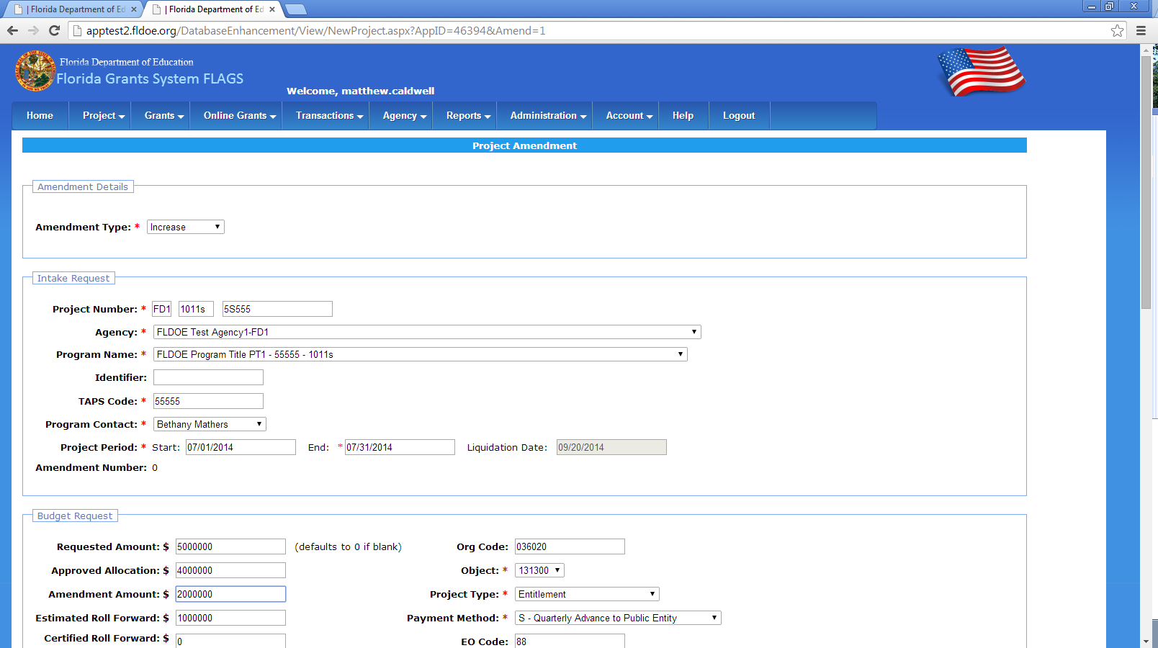

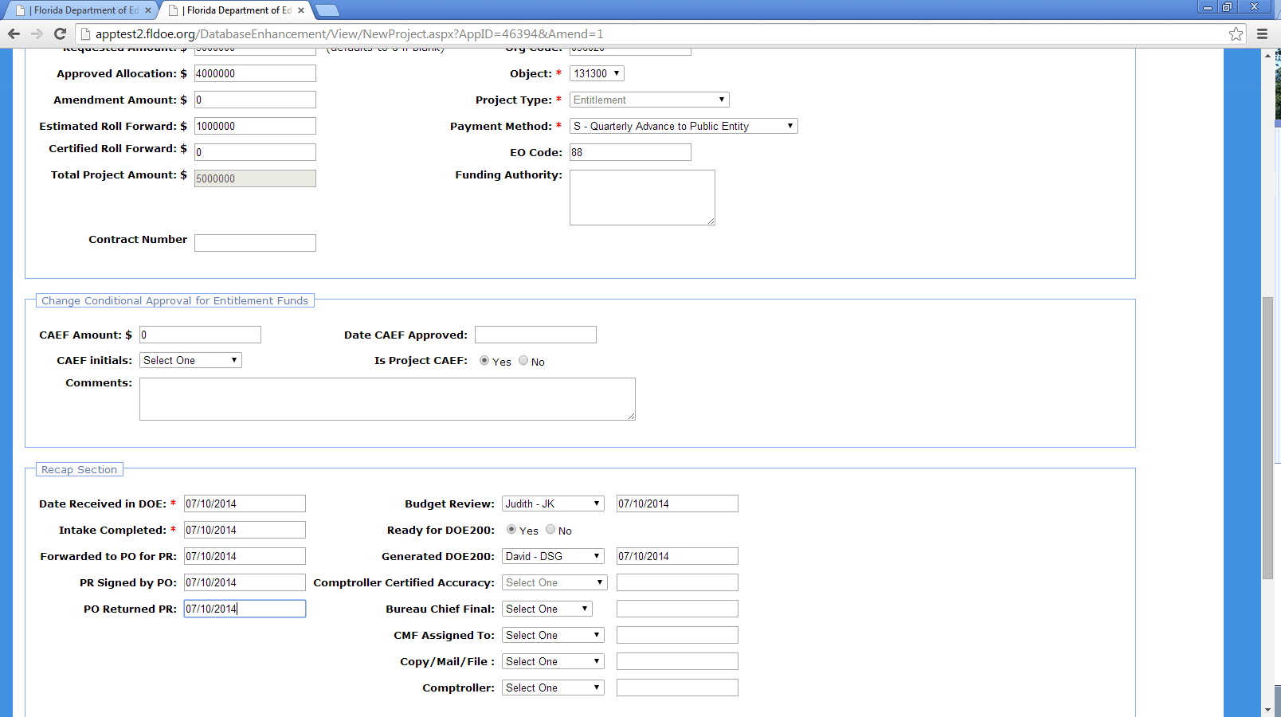
- After adding an amendment the project status is changed to Project Amendment in Project List page
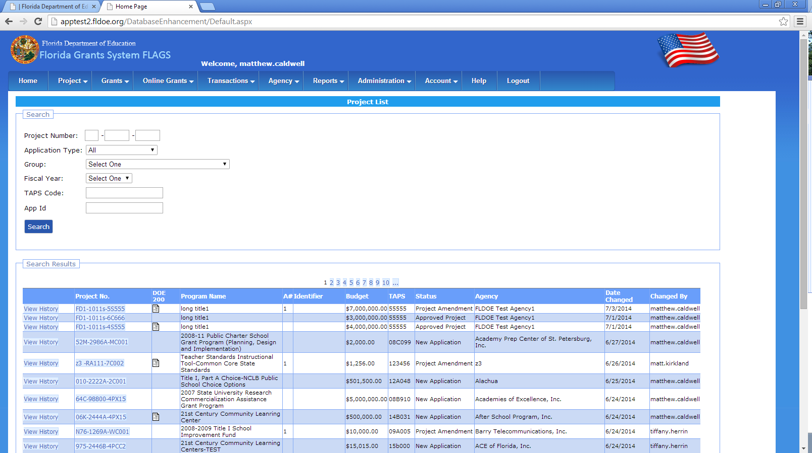
- Comptroller should approve the amended project
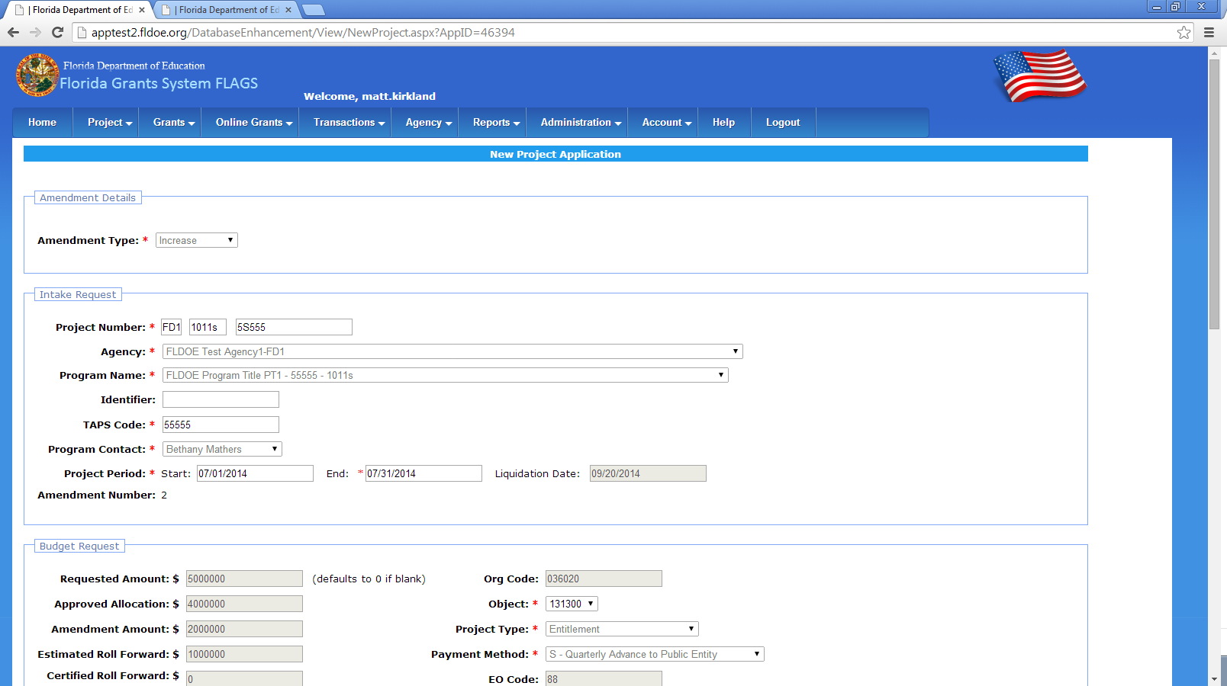
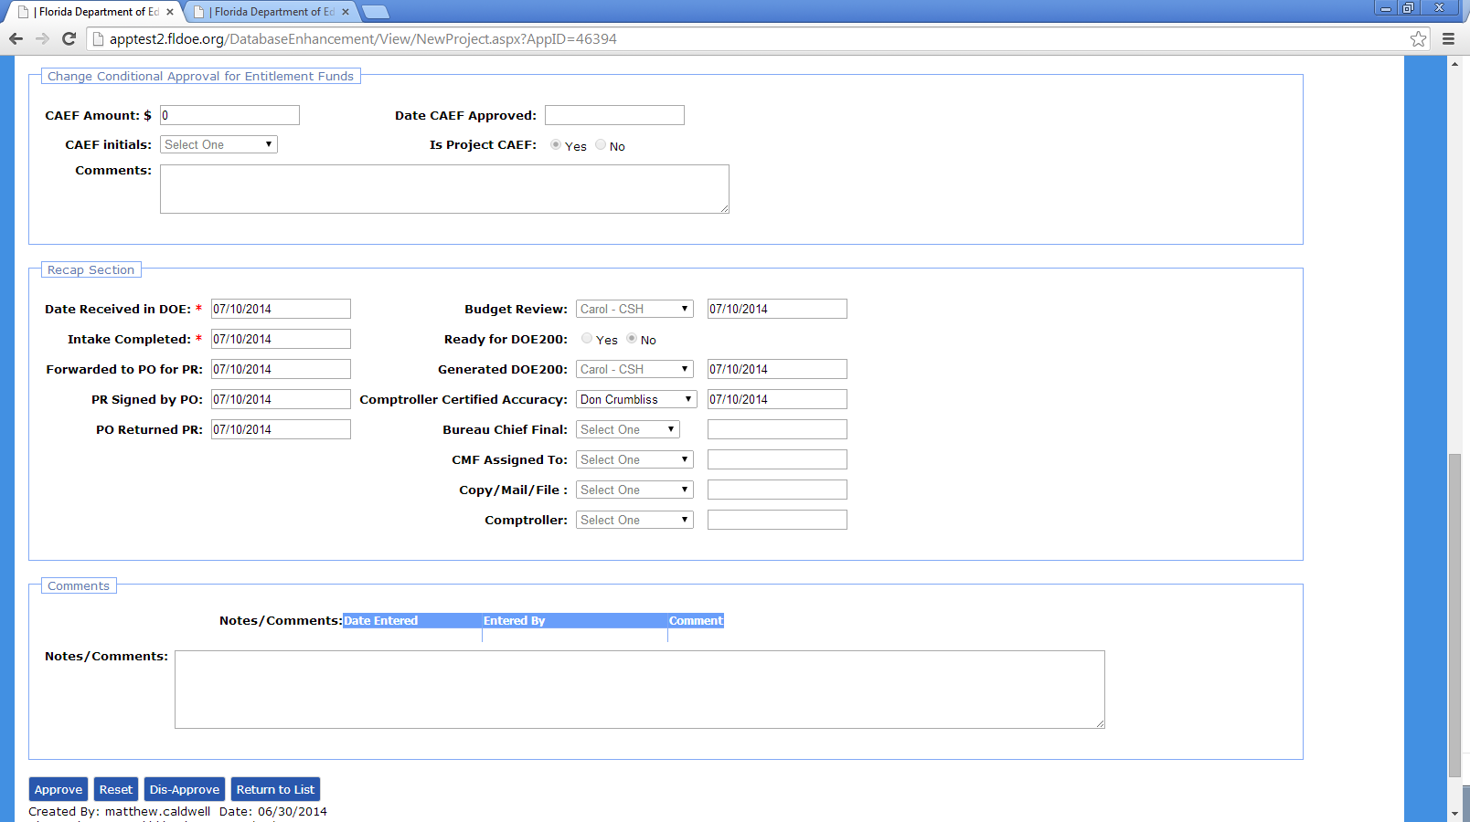
- It should again be approved by Grants
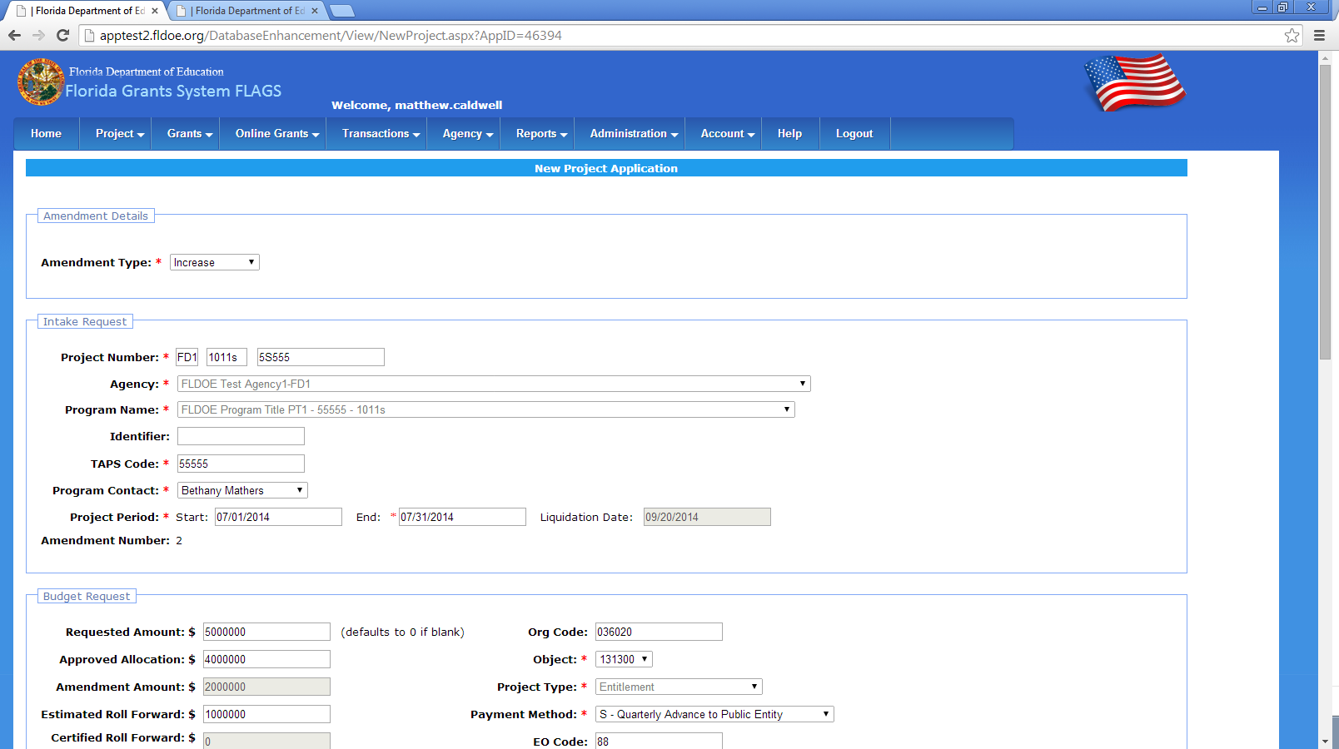
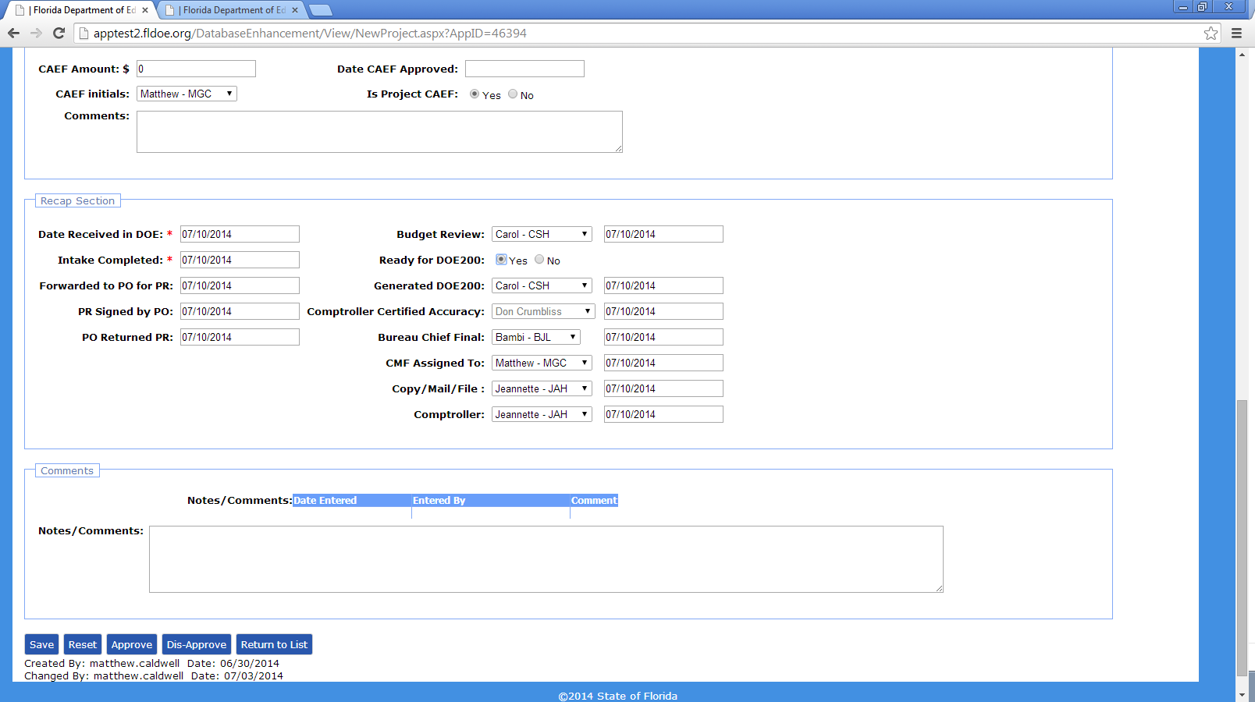
- Project state is changed to approved in project list
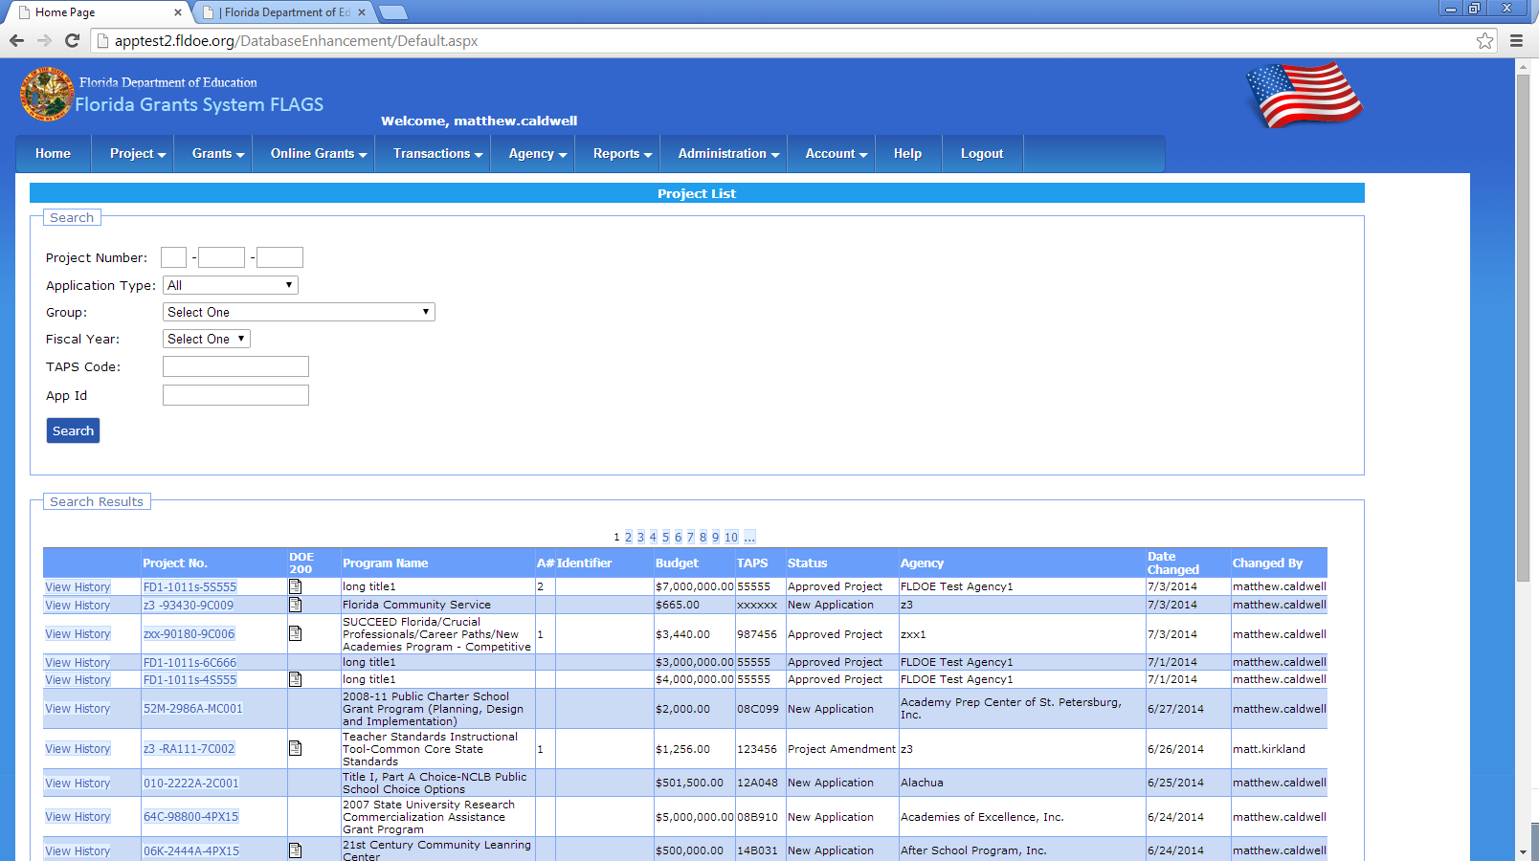
- Once the amendments were approved they are shown in comptrollers home screen under amended projects awaiting approval
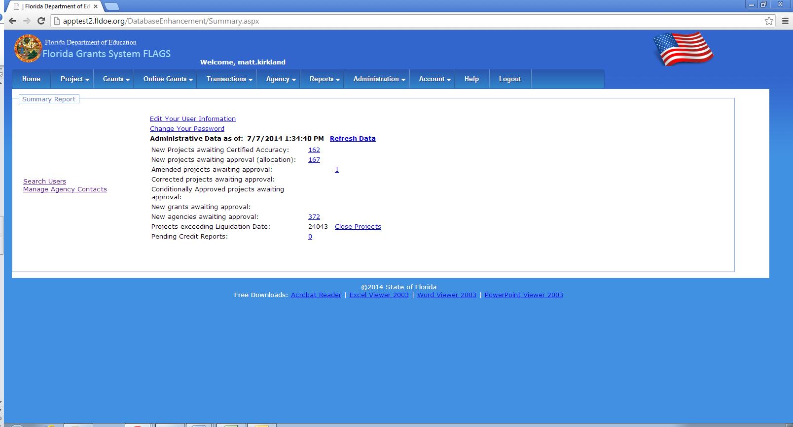
- Comptrollers will approve the amendment by clicking on apply amendment
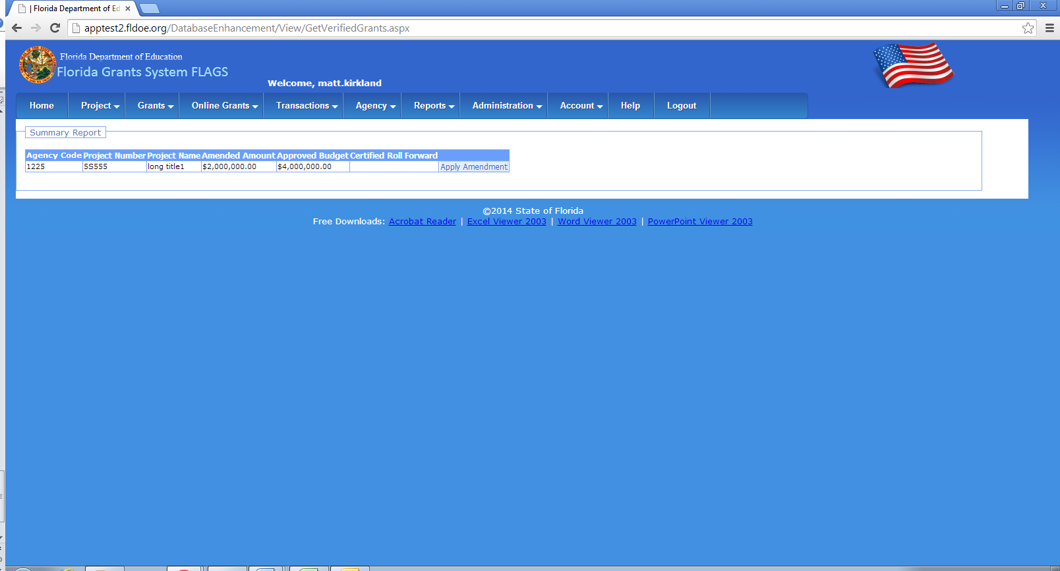
- In Project master page the amendment can be approved
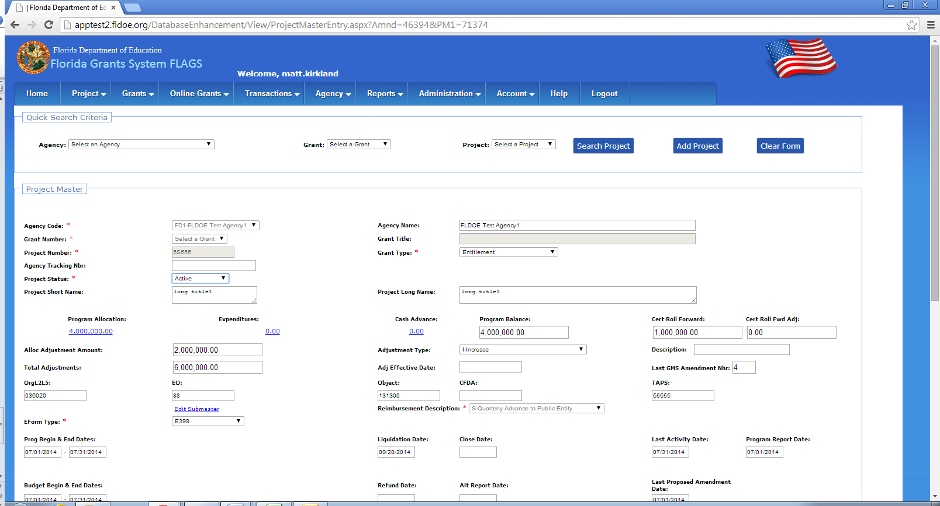
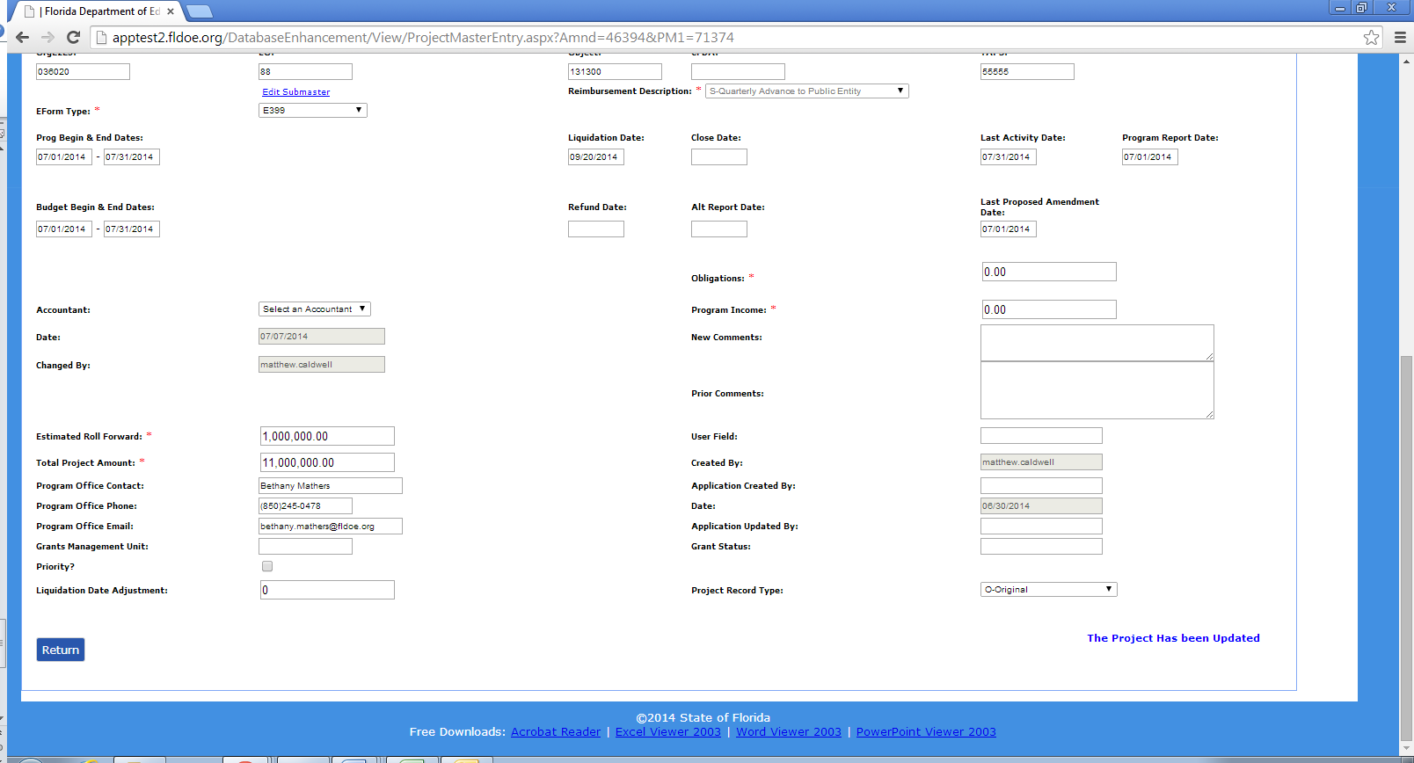
- After clicking the save button “The project has been updated” message will be displayed
- After the comptroller has saved the project in project master it was not shown in the comptrollers home screen anymore
