**Project Application**

**A new Project Application can be created by (Roles):**

1. Flags Admin
2. Flags Read-only
3. Internal/DOE
4. Comptroller Sys Admin

**Steps to create a New Project:**

1. Select an agency, which gives the first three characters in project number
2. Select a Program name, that gives the next first characters in project number
3. Enter the last five characters in the project number, second character in the last five characters should match with payment method
4. Project end date must be greater than begin project date
5. Liquidation Date is calculated after 51st day after project end date
6. In recap section Intake completed should be greater than Date Received in DOE

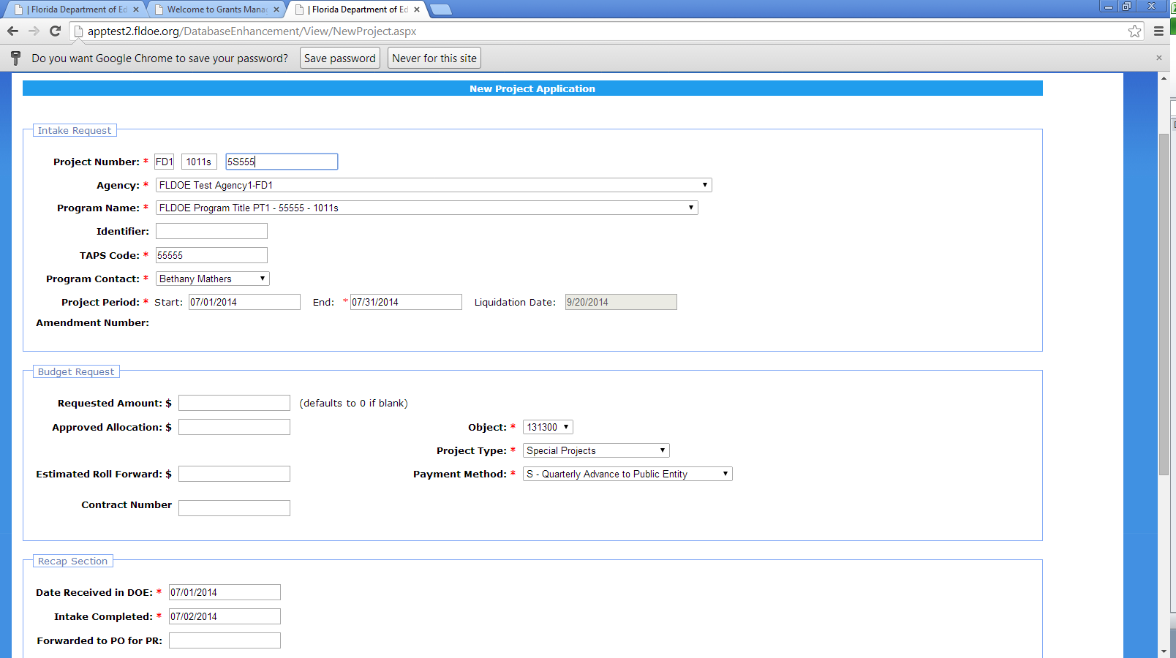

1. After saving the project it was redirected to project list and the project is shown on the top

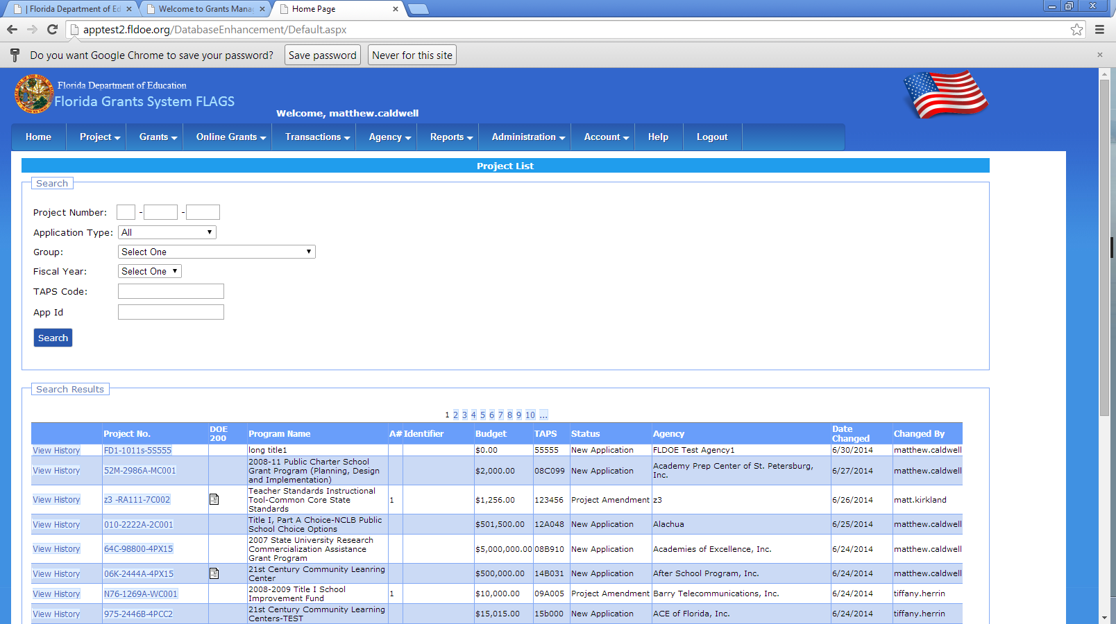

1. To Approve the project click the project no from project list and then

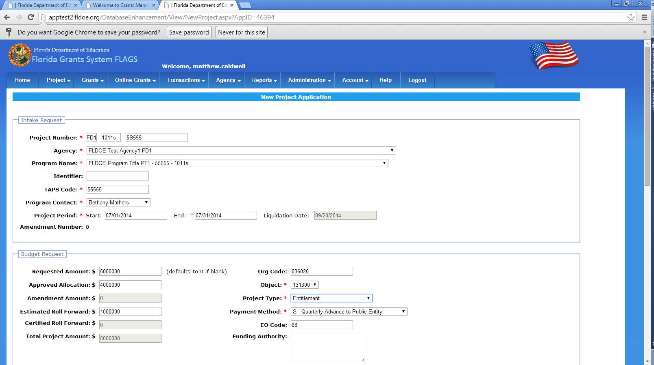

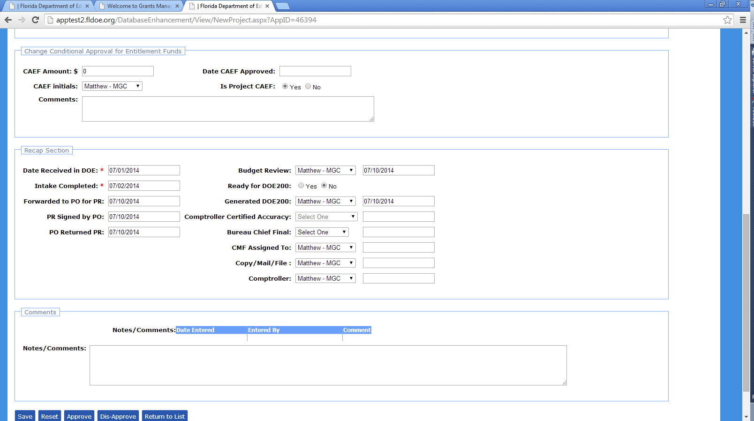

1. When Requested amount, Approved Allocation & Estimated Roll Forward is given, total amount is added and shown in total Project Amount
2. If there is any amount in Estimated roll forward then project type should be entitlement
3. Comptroller will approve the project by giving the comptroller certified accuracy date

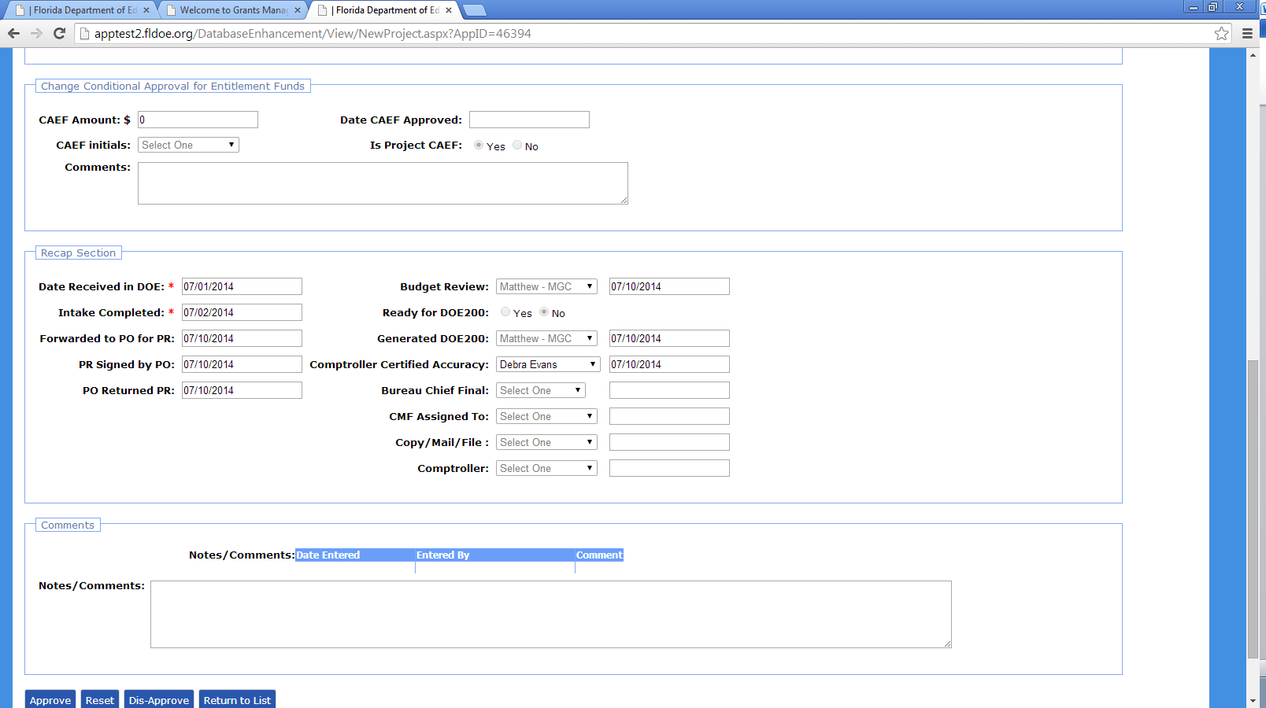

1. Once the project is approved by comptroller, it should be saved by grants

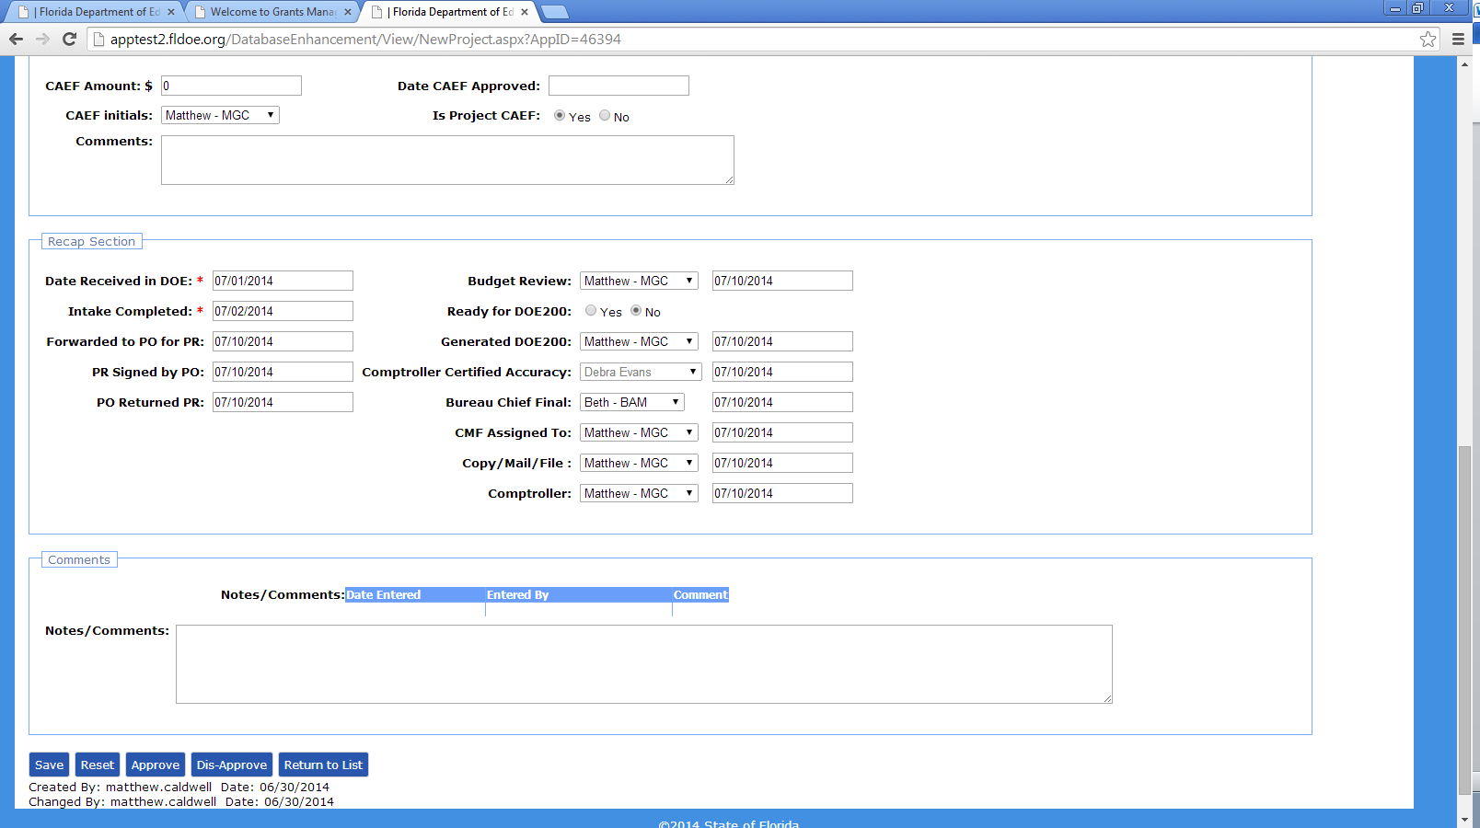

1. The project should be then approved by Grants

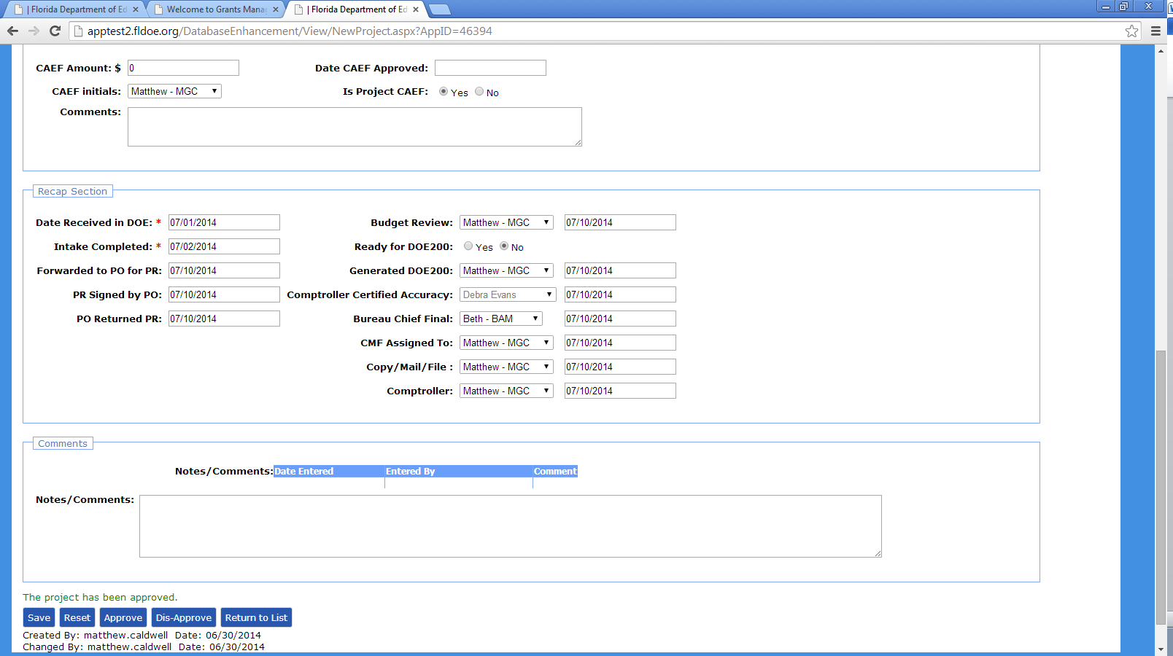

1. The project status is changed to approved in the project list

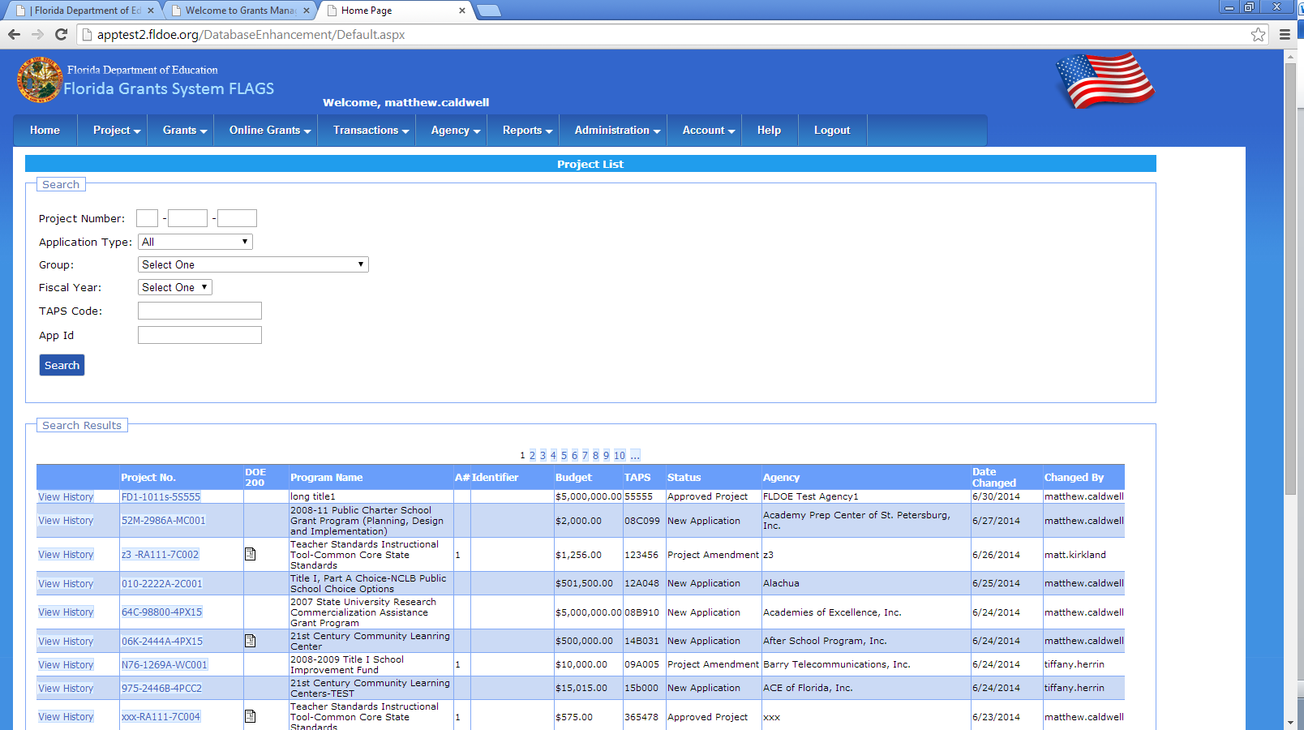

1. Once the project is approved everything in the project is disabled
2. Ready for DOE 200 document can be generated if Ready for DOE200 document is selected as yes and can be seen in project list