Review Amendments (DOE Staff)
To begin the process of reviewing submitted amendments, click on the Review Amendments link found under the “Scope of Work (SOW)” section of the Program Main Menu page. This will take you to the Amendment Review List page.
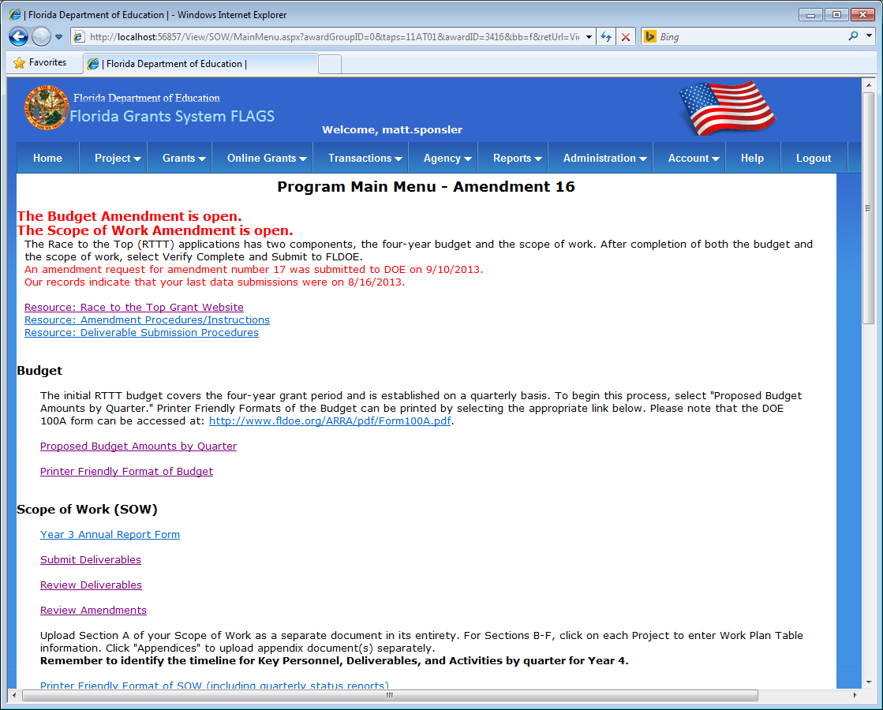
Figure 38 - Program Main Menu

The Amendment Review List page displays any Budget and Scope of Work changes made in the most recently submitted project amendment. Click on the “Review” button found in the rightmost column of the amendment change list to navigate to the Amendment Review Detail page.
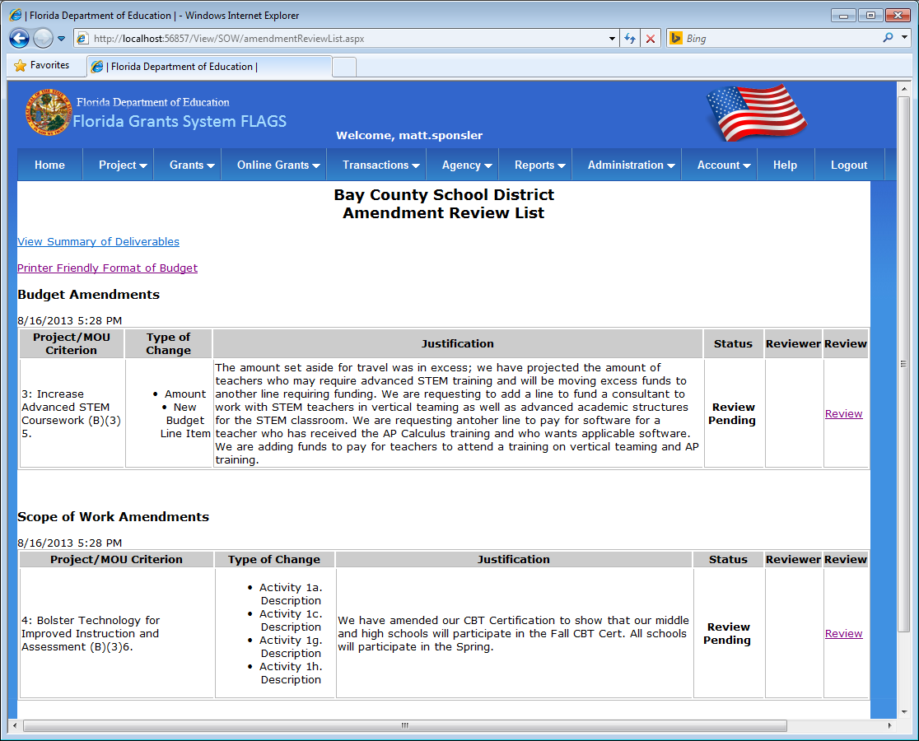
Figure 39 - Amendment Review List

The Amendment Review Detail page lists the details and justification submitted for the changes made in the most recent project amendment as well as the review history for any other reviews entered for this set of amendment changes.
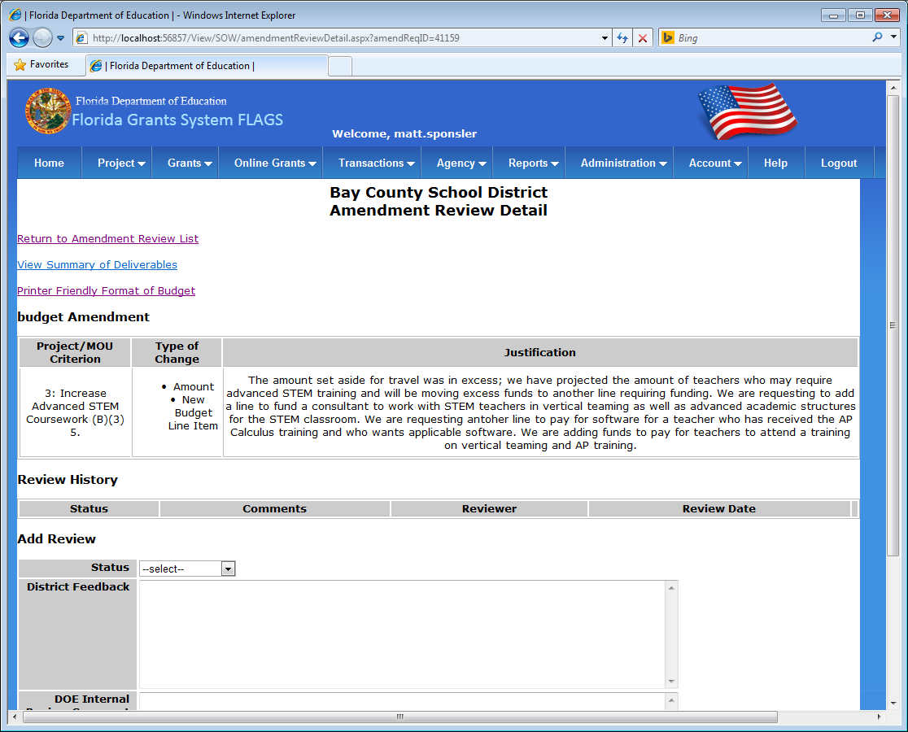
Figure 40 - Amendment Review Detail

To add a new review for this set of amendment changes, fill out the fields found under the “Add Review” section of the page, beginning with the “Status” field, as seen below.
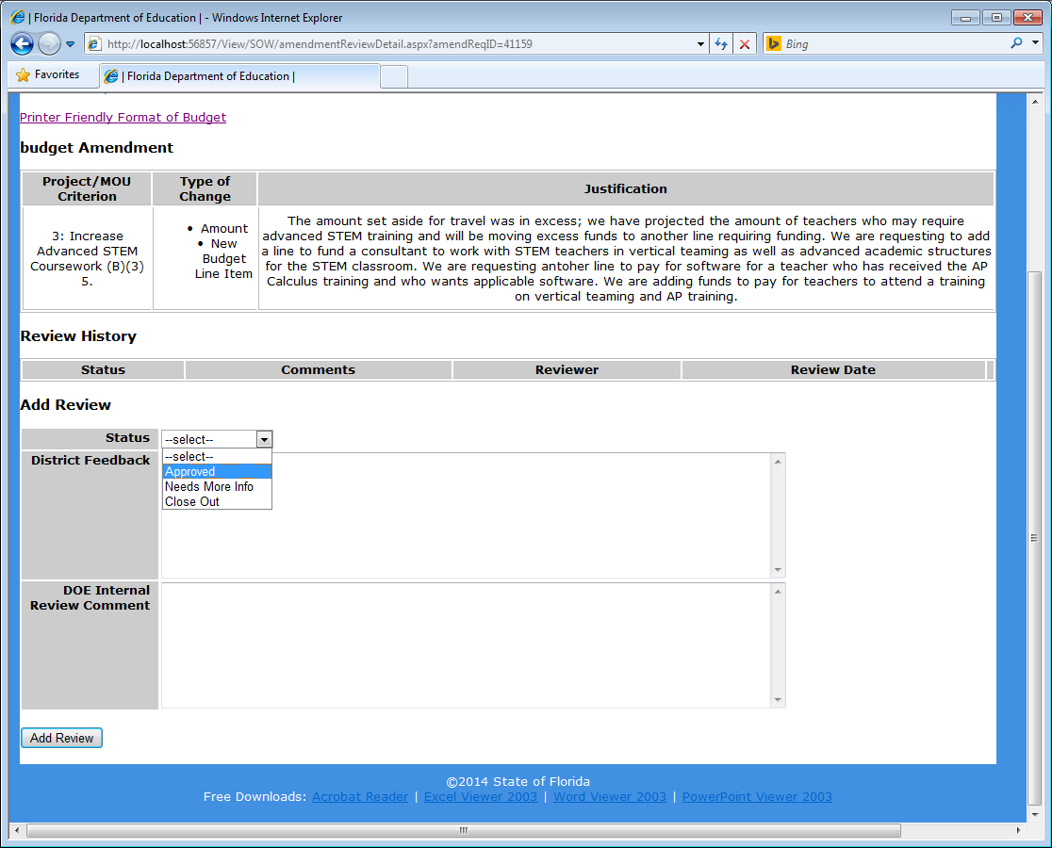
Figure 41 - Select Status

After completing all fields under the “Add Review” section of the page, click the “Add Review” button found on the bottom of the page to add a new review to this set of amendment changes.
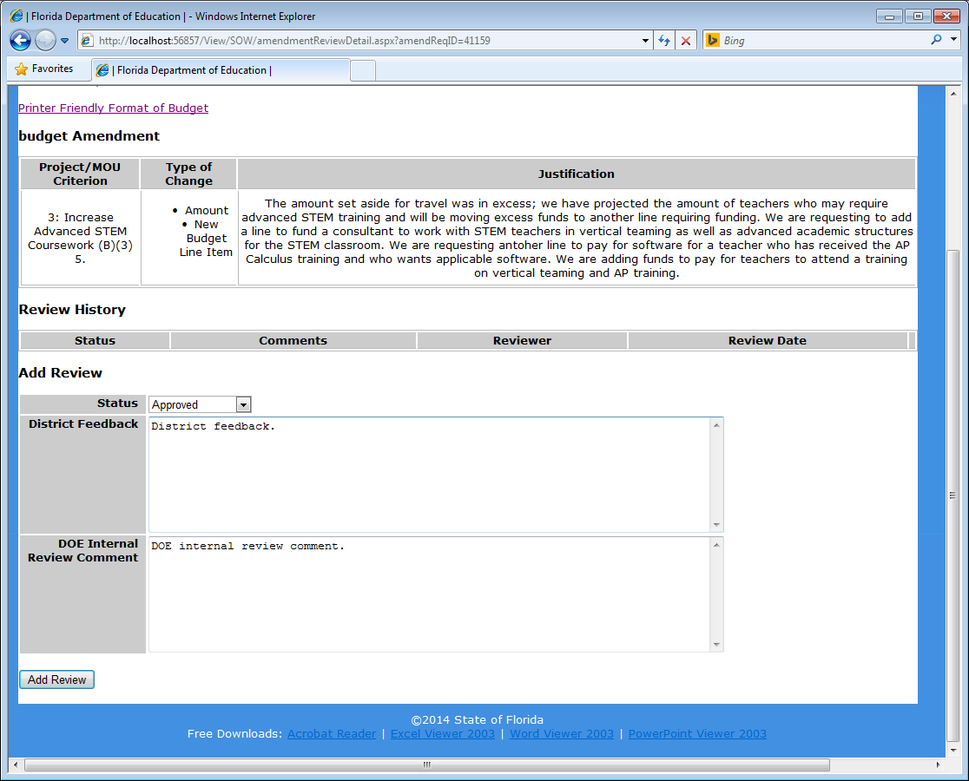
Figure 42 - Add Review

After clicking the “Add Review” button, the review will be added to the “Review History” section of the page. There may be multiple review records for each set of amendment changes. The most recently added review is treaded as the current, or active review.
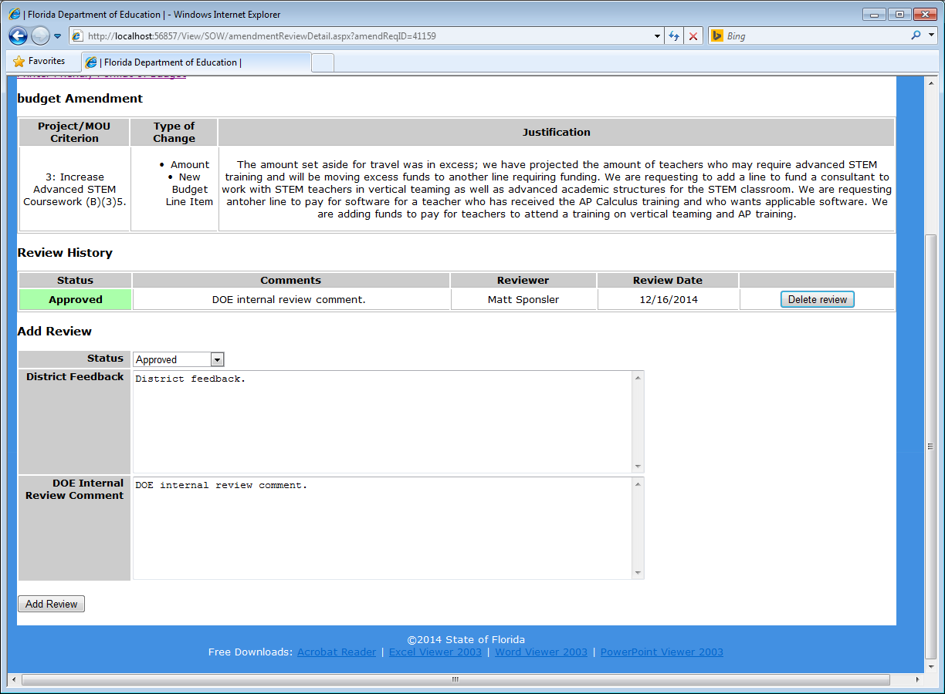
Figure 43 - Review History

You may return to the Amendment Review List page by clicking the “Return to Amendment Review List” link found at the top of the page. As seen below, the Amendment Review List page lists the most recent review in the Review Status column amendment change list. Subsequent reviews may still be added by returning to the Amendment Review Detail page using the “Review” link.
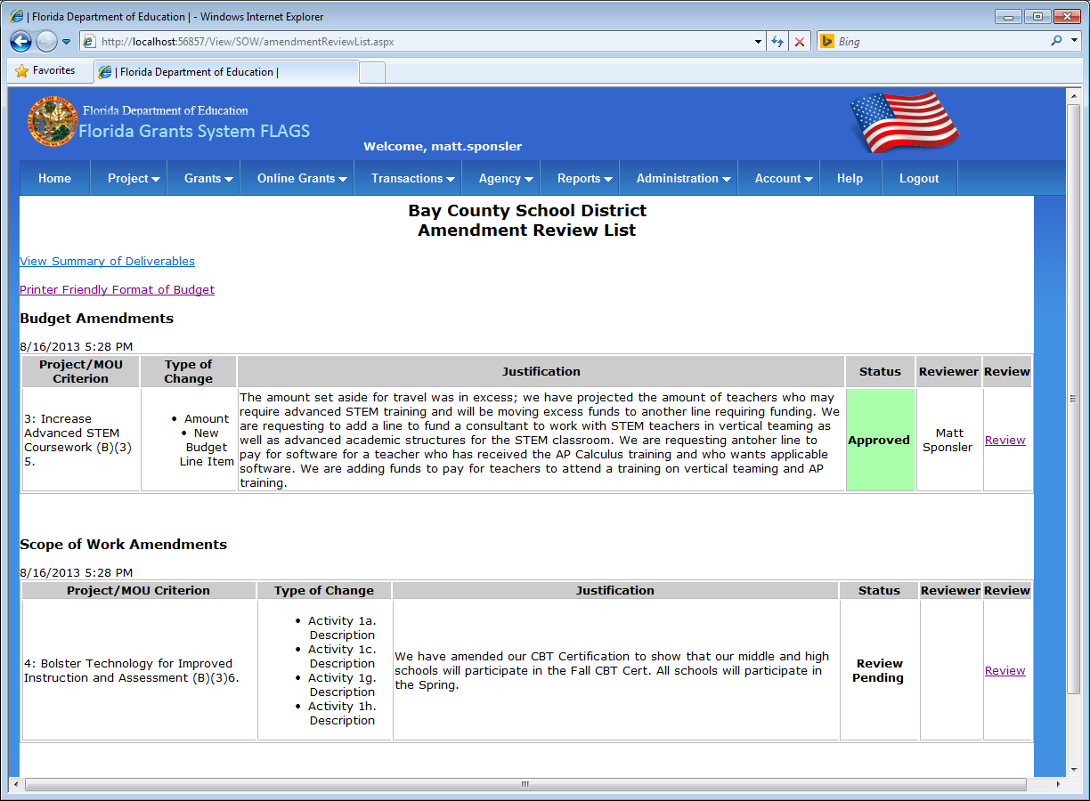
Figure 44 - Amendment Review List

