**Submitting Deliverables (Award Recipient)**

To begin the process of submitting deliverables for a project, begin on the Program Main Menu page, as seen below. Click on the “Submit Deliverables” link under the “Scope of Work (SOW)” section of the page. This will take you to the Deliverable Due List page.

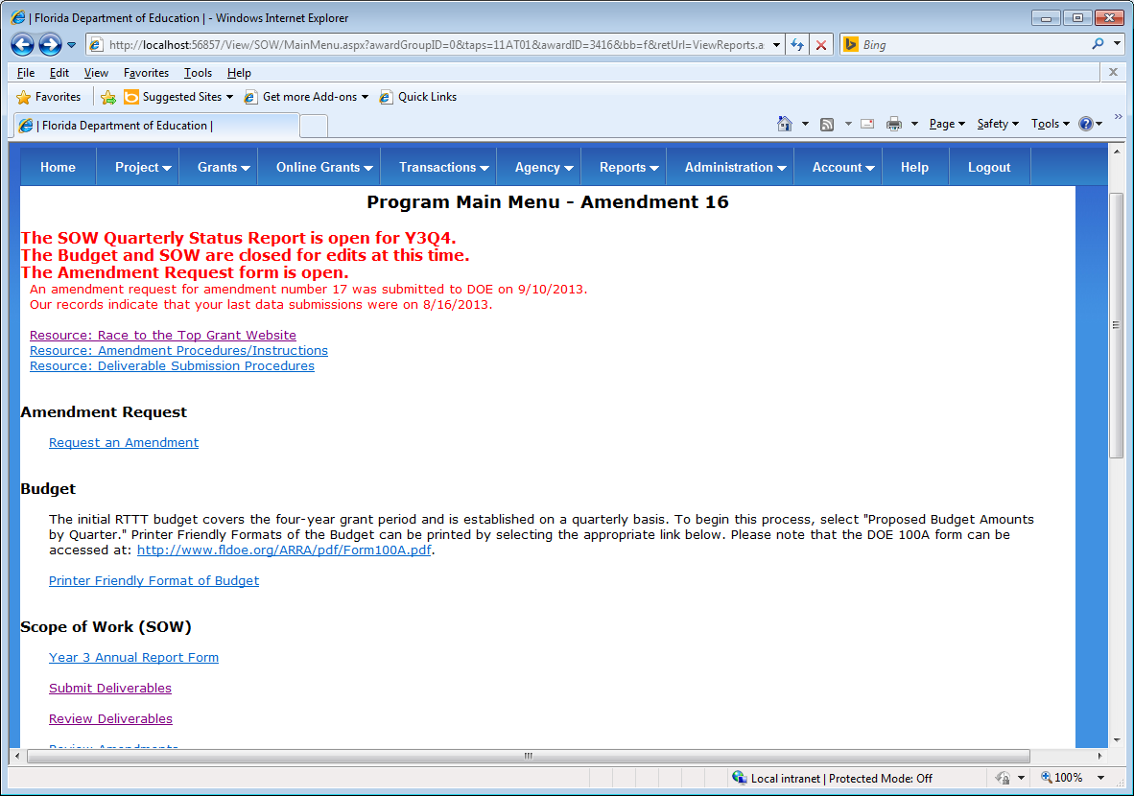

Figure 21 - Program Main Menu

On the Deliverable Due List page, you will find a list of deliverables which are due for a chosen reporting period and Project/MOU Criterion. To view deliverables for other reporting periods and Project/MOU Criterion, select the chosen values from the drop down list inputs and then click on the “Go” button.

Click on the “Submit Deliverable N” button to take you to the Submit Deliverable page.

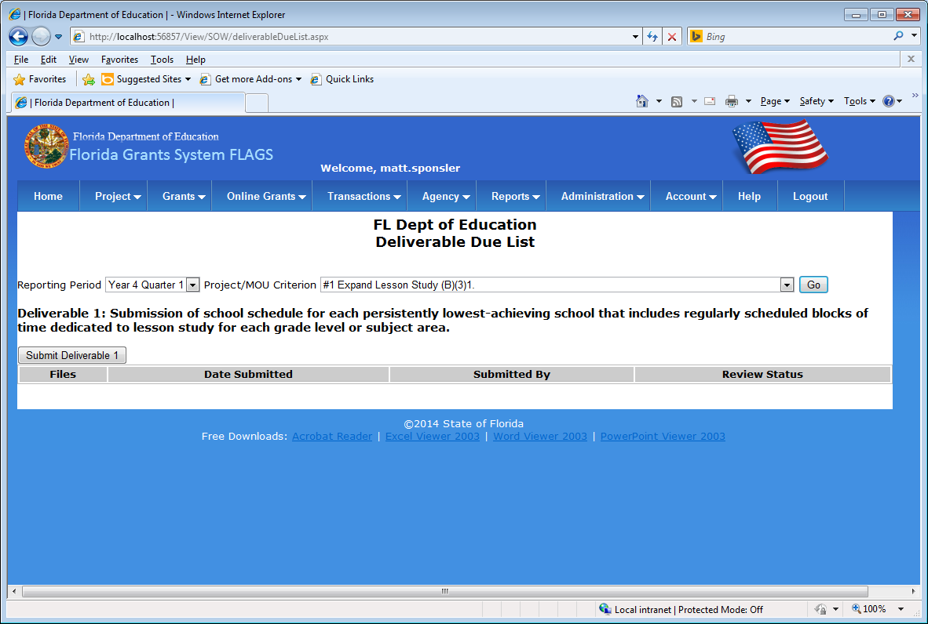

Figure 22 - Deliverable Due List

On the Submit Deliverable page, you may attach multiple files to the deliverable record and add comments before submitting the deliverable off to DOE.

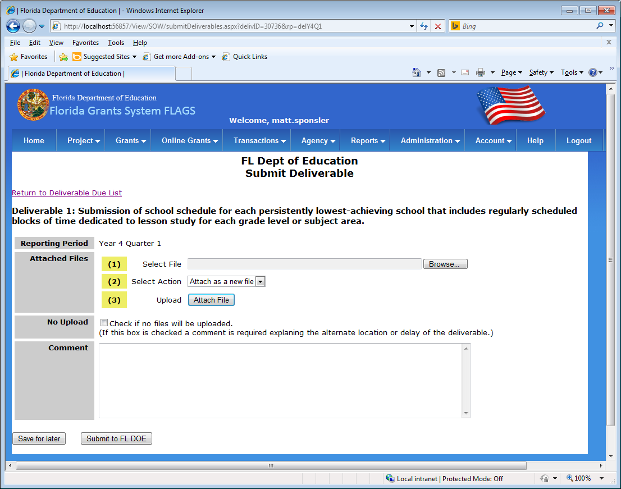

Figure 23 - Submit Deliverable Page

To attach a file to the deliverable record, click on the “Browse…” button to the right of the first step (1) of the “Attached Files” section of the page. This will open a window where you can select a file on your local computer or network.

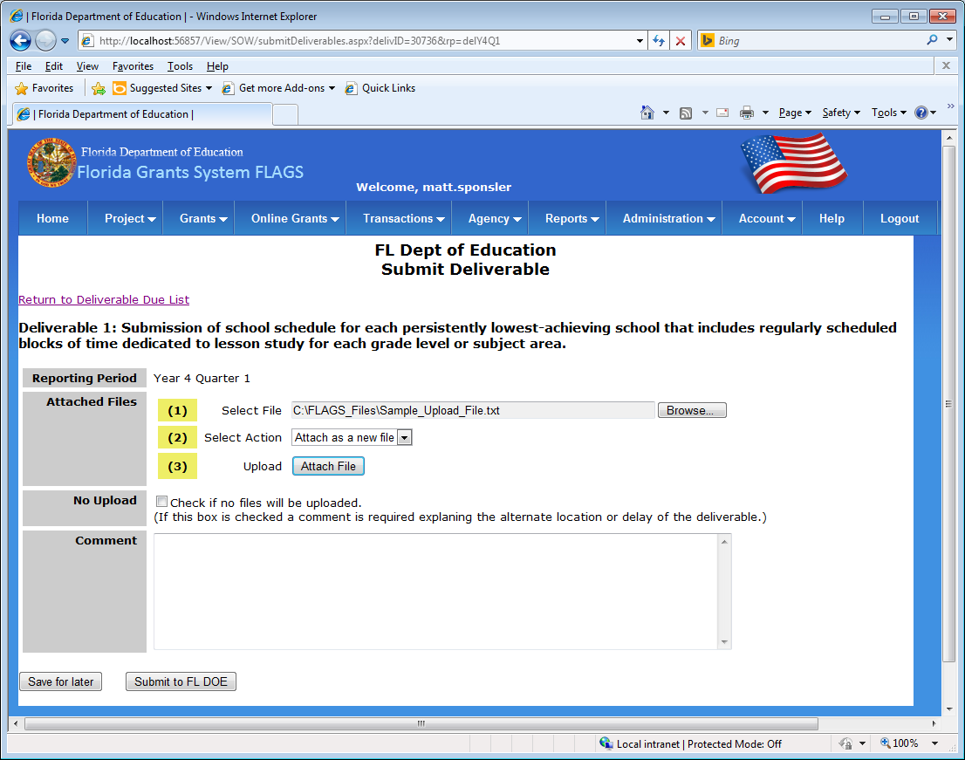

Figure 24 - Select File

After selecting a file to attach to the deliverable record, click the “Attach File” button on step three (3) of the Attached Files section of the page. Any files attached to the deliverable record will display at the top of the “Attached Files” section of the page. To remove an attached file, just click on the “remove file” button next to the filename.

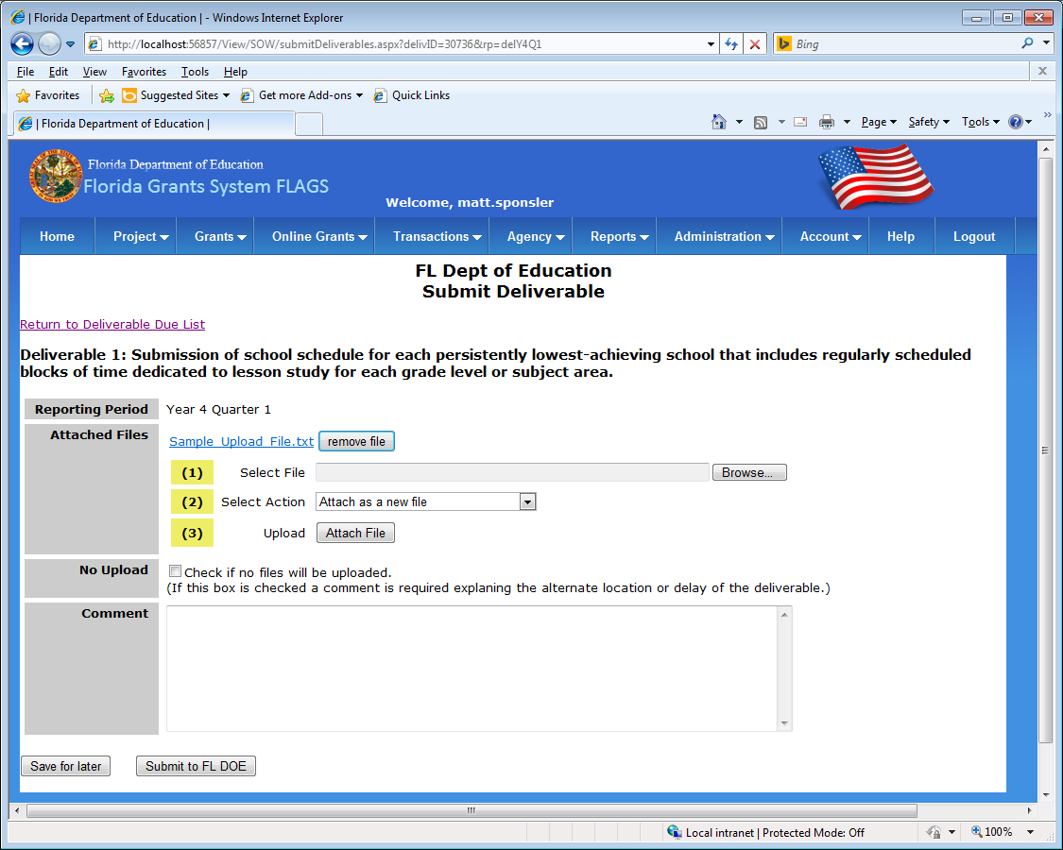

Figure 25 - Attach File

Once a file has been attached to the deliverable record, you may choose to upload a second file (or more) to the deliverable. The “Select Action” step (2) gives you the choice of either attaching the selected file as a new file, or to replace one of the already attached files on the deliverable record.

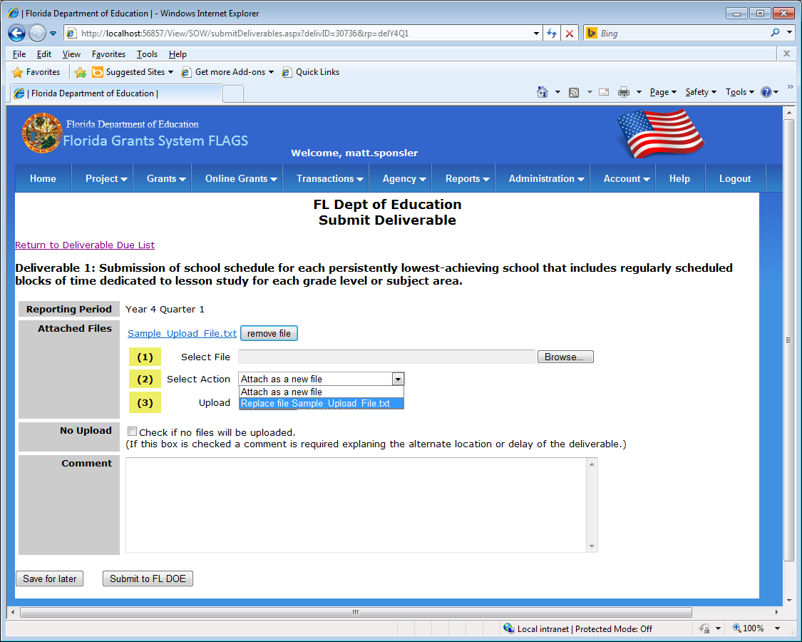

Figure 26 - Replace File

Once all of the desired files have been attached to the deliverable record, complete the Comment section of the page. You may now either save this deliverable record if you are not yet ready to submit the record to FL DOE by clicking the “Save for later” button in the lower left corner of the page. Or if you are ready to submit the deliverable to FL DOE, click the “Submit to FL DOE” button.

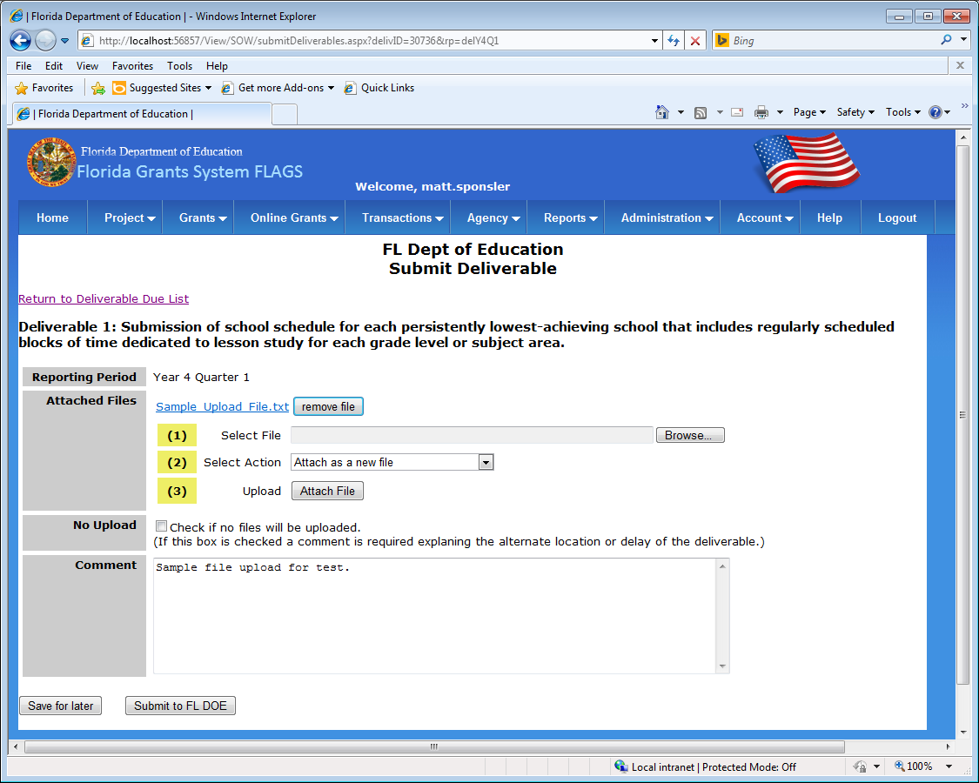

Figure 27 - Add Comments

If you click the “Save for later” button, you will be taken back to the Deliverable Due List page. Notice in the screenshot below, that the deliverable record is present in the list, but it has not yet been submitted to FL DOE.

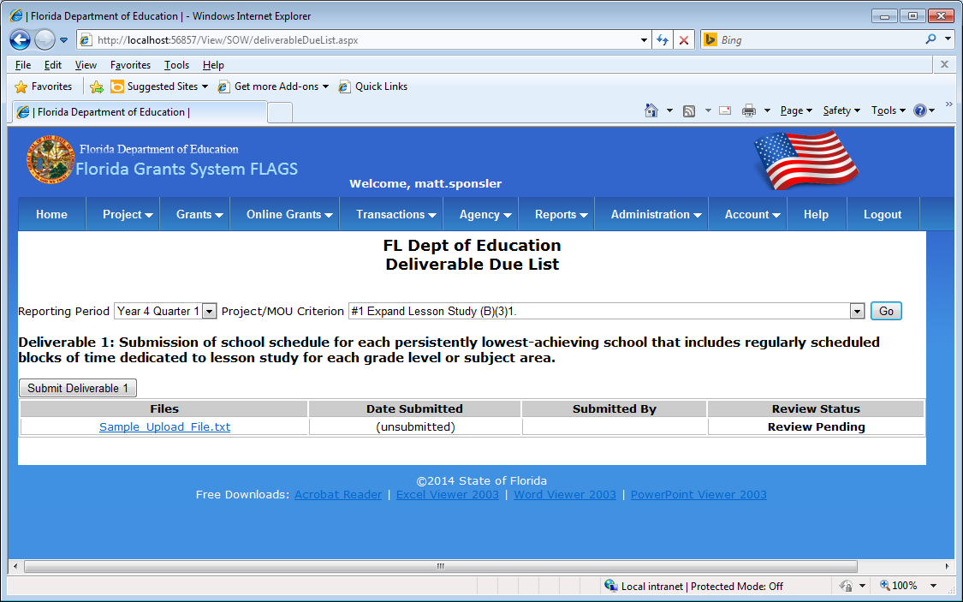

Figure 28 - Deliverable Due List, Unsubmitted Deliverable

Once you are ready to submit the deliverable record to FL DOE, click on the “Submit to FL DOE” button on the Submit Deliverable page. A confirmation window will appear with the options “OK”, or “Cancel”.

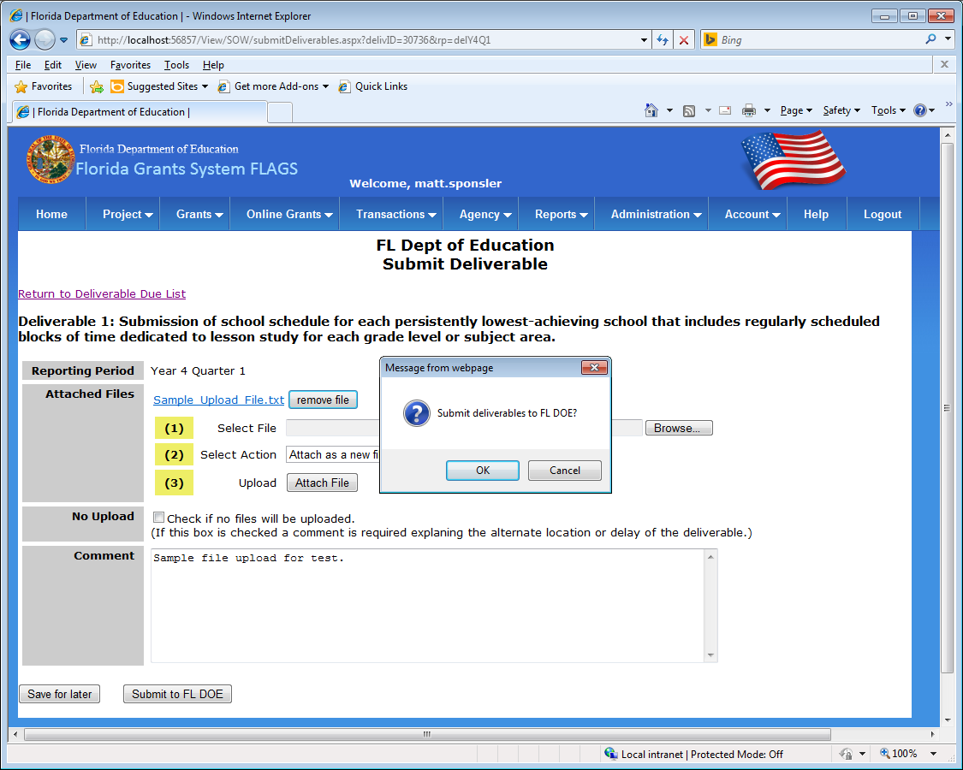

Figure 29 - Submit Deliverable

Once the deliverable has been submitted to FL DOE, you will be redirected back to the Deliverable Due List page. Notice in the screenshot below that the “Date Submitted” and “Submitted By” fields are now populated for the submitted record. The “Review Status” field will show as “Review Pending” until the FL DOE staff have had a chance to review the deliverable record and files, after which the Review Status will either show as “Approved” or “Needs More Info”.

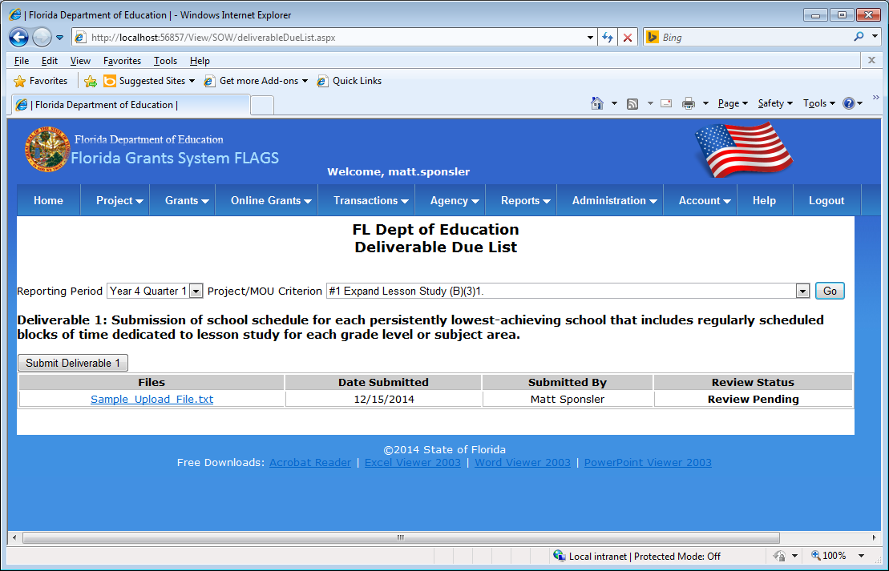

Figure 30 - Deliverable Due List, Submitted Deliverable